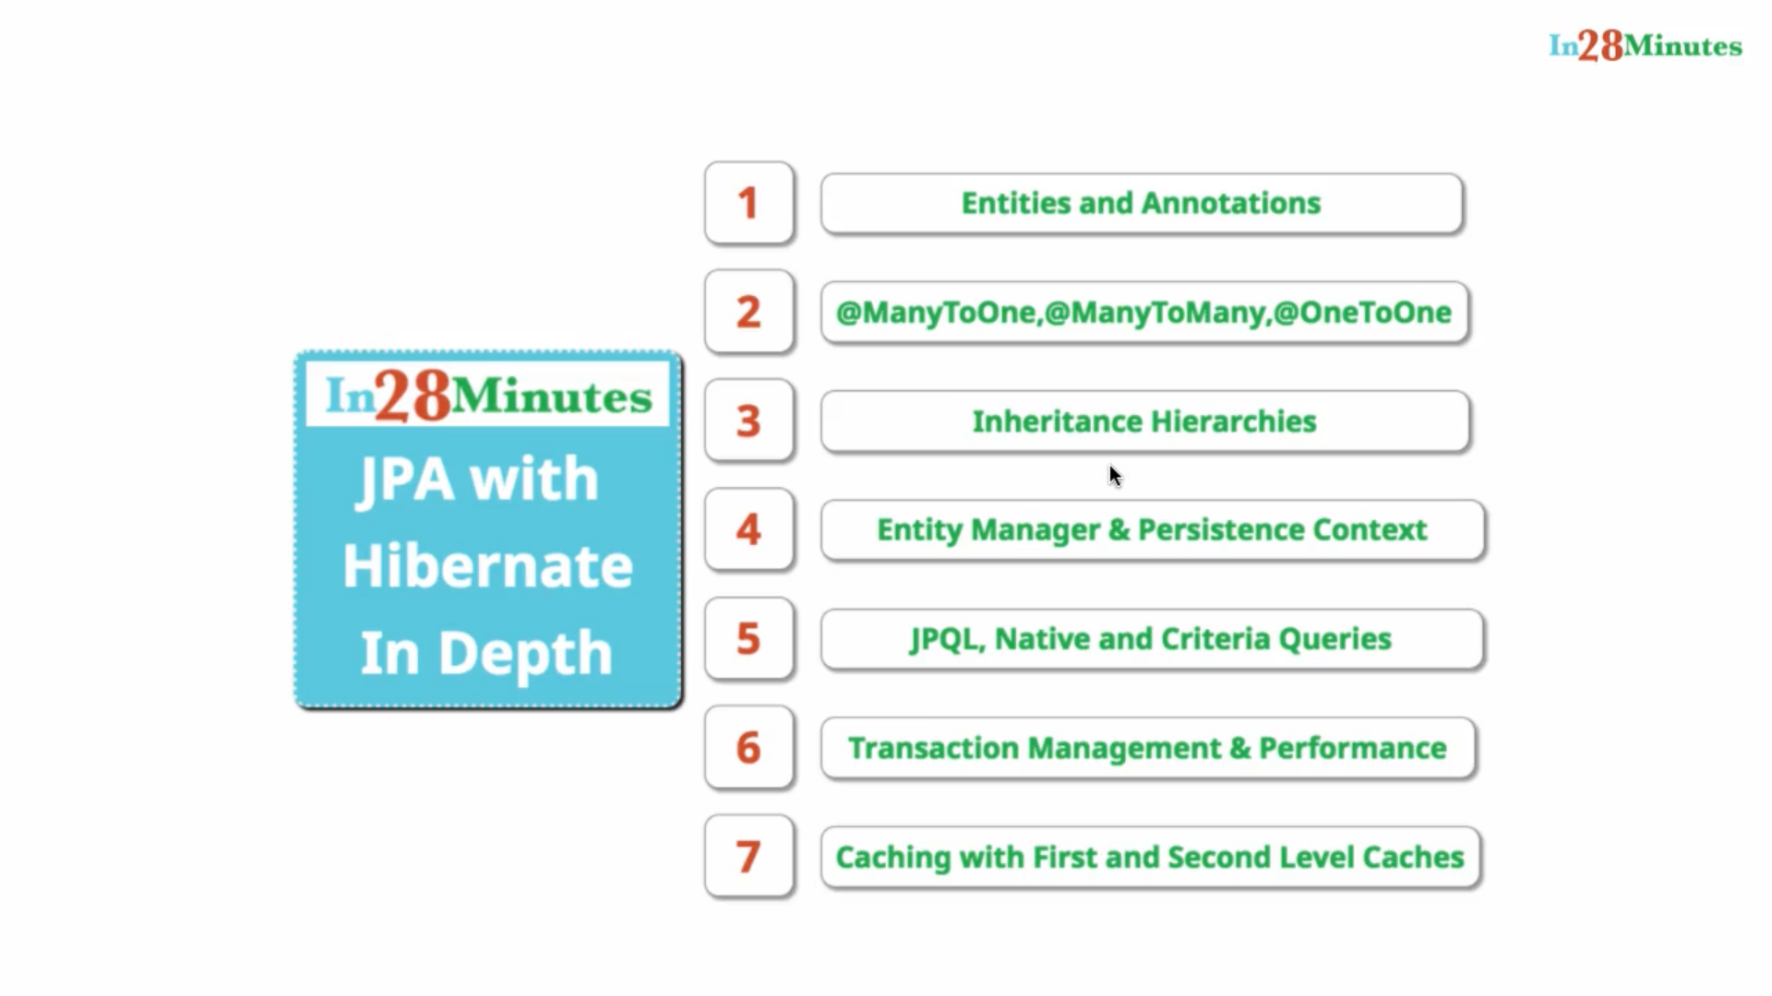

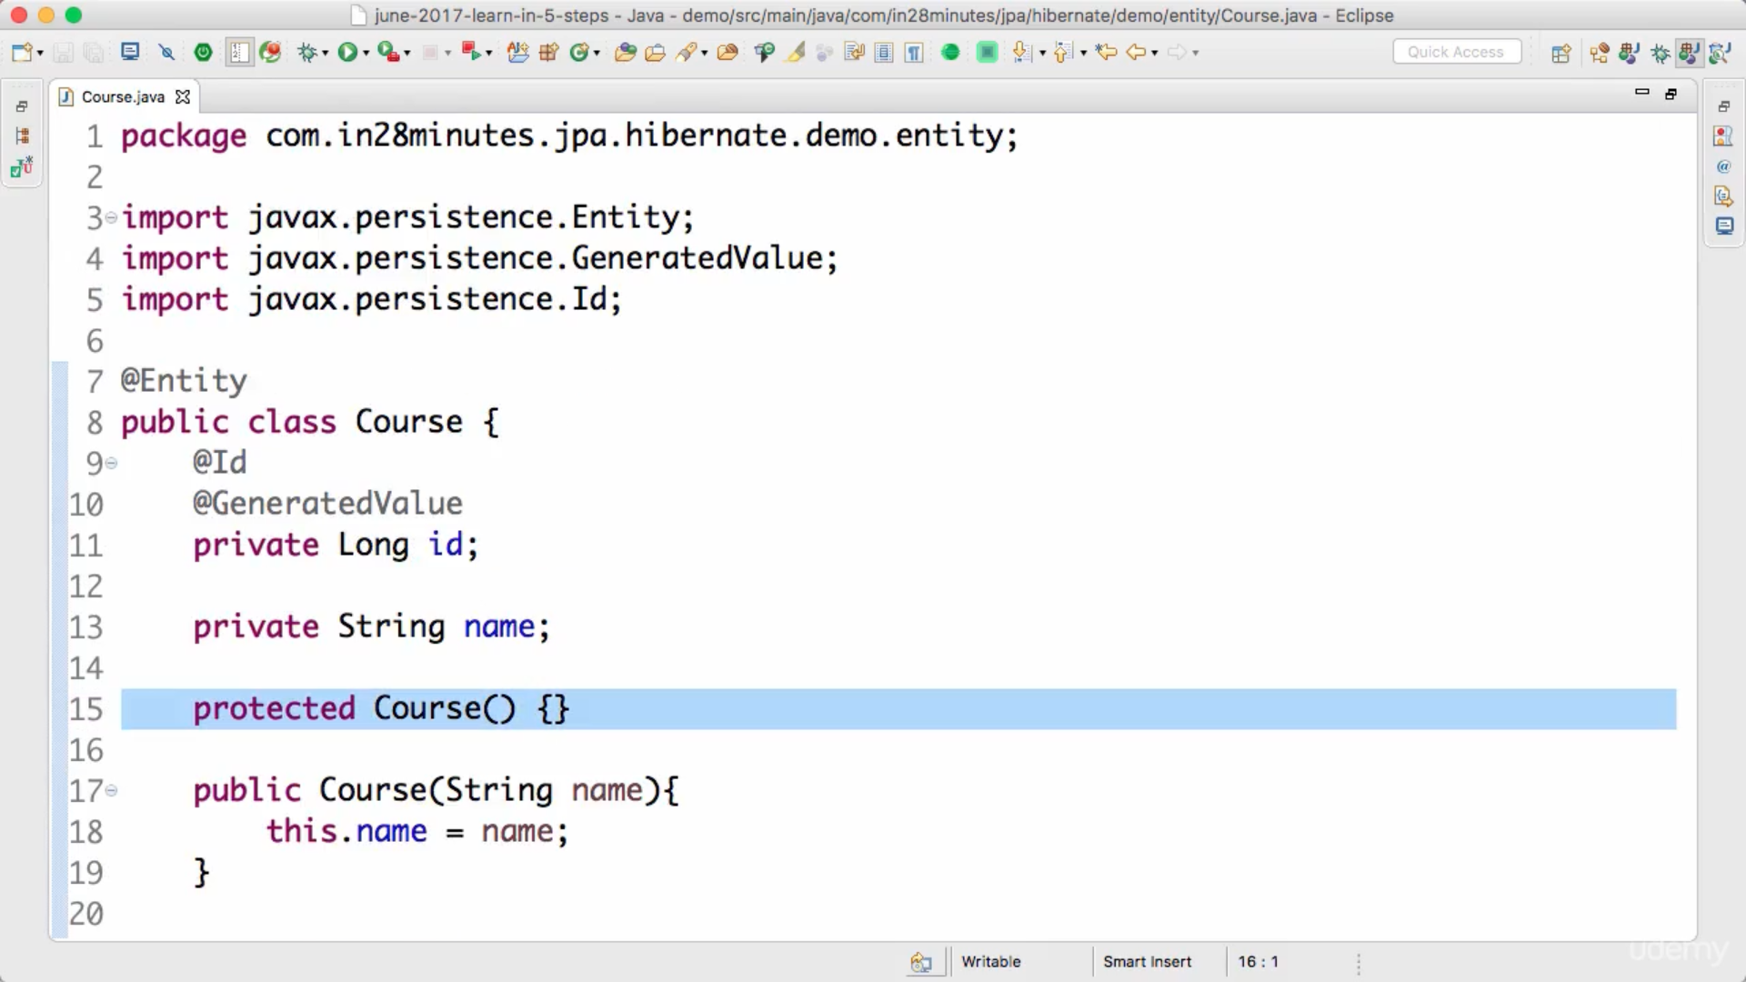

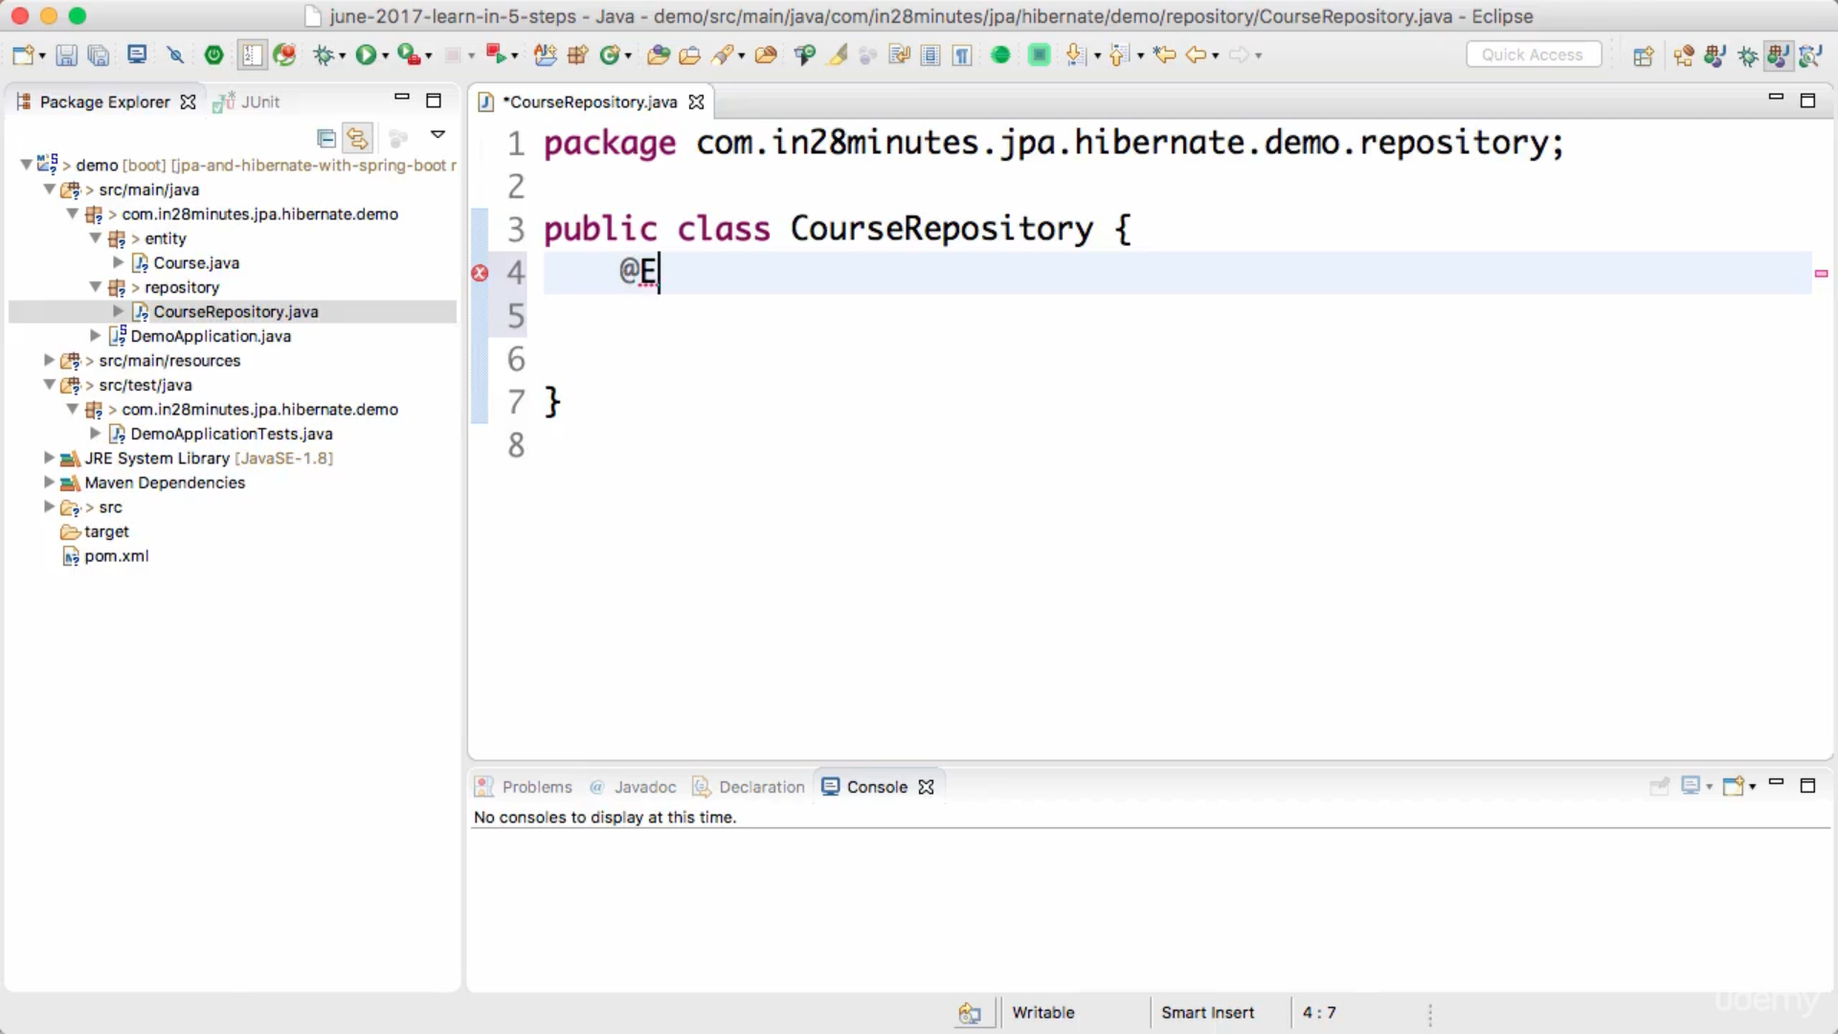

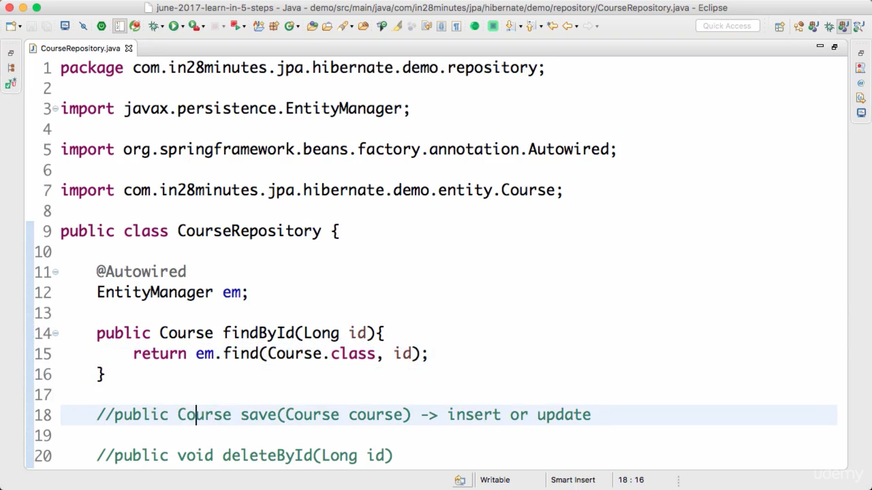

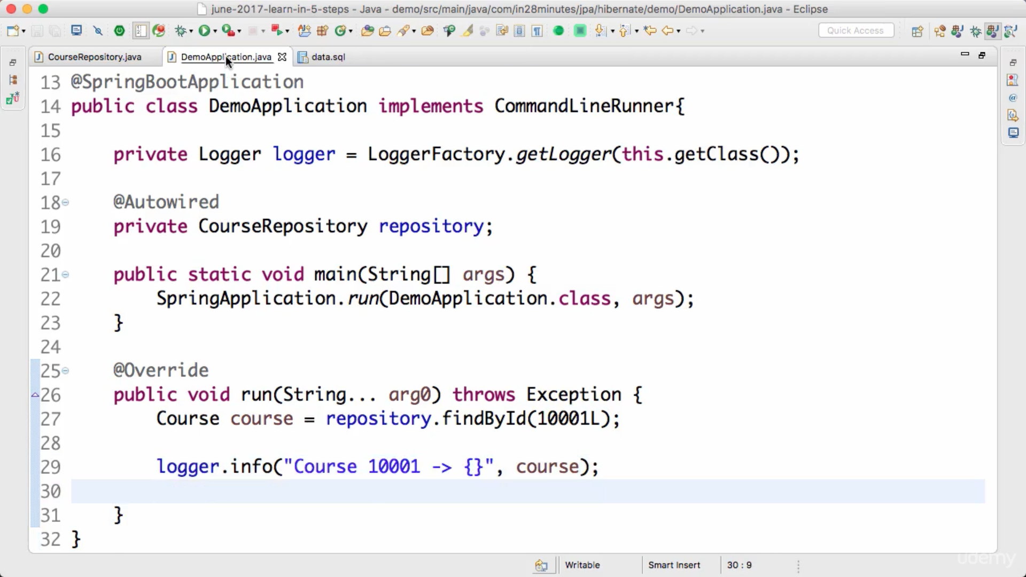

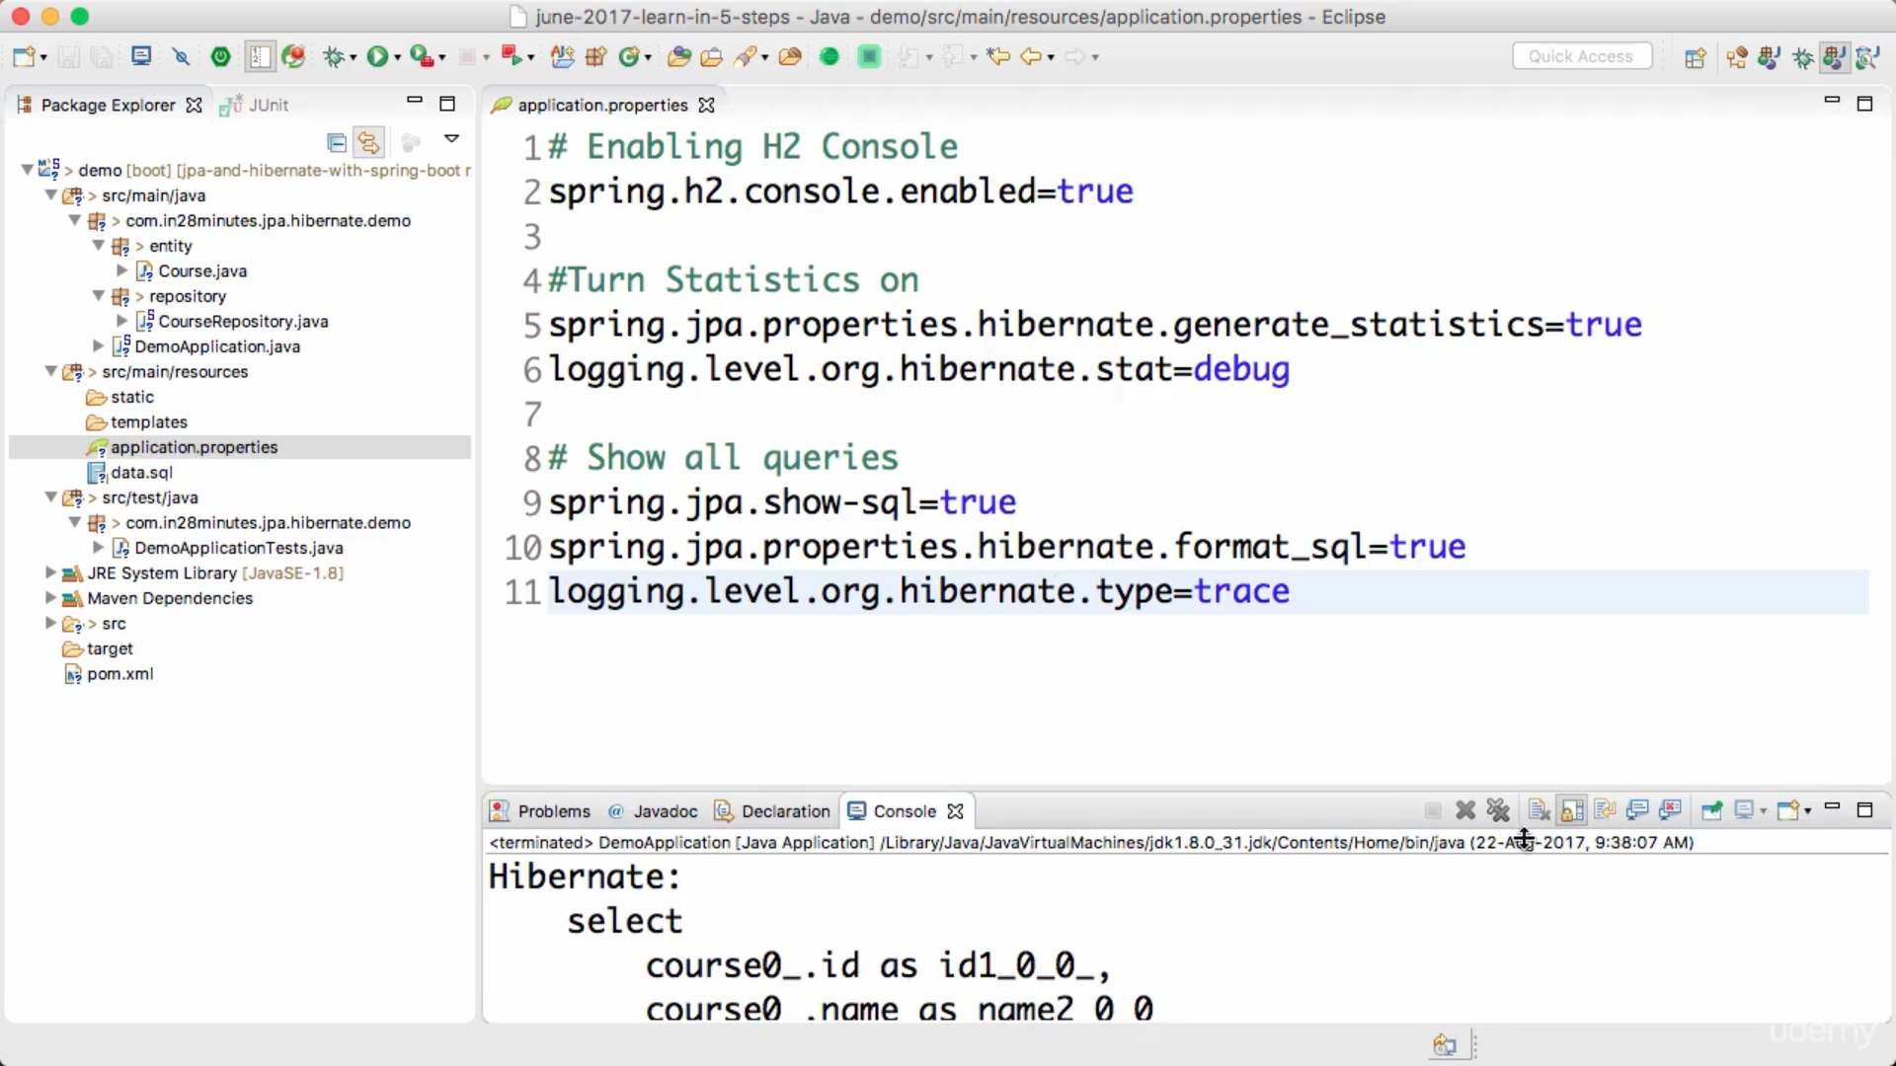

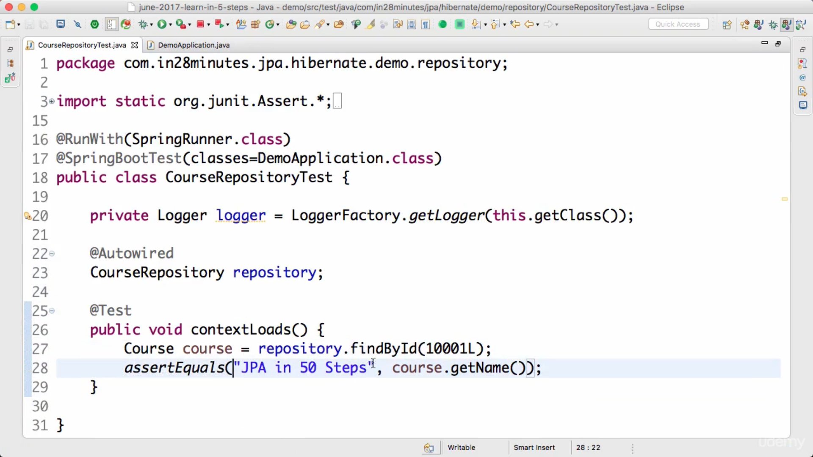

@transactional : from spring is added to repository class, so that every method become transactional implicitly.

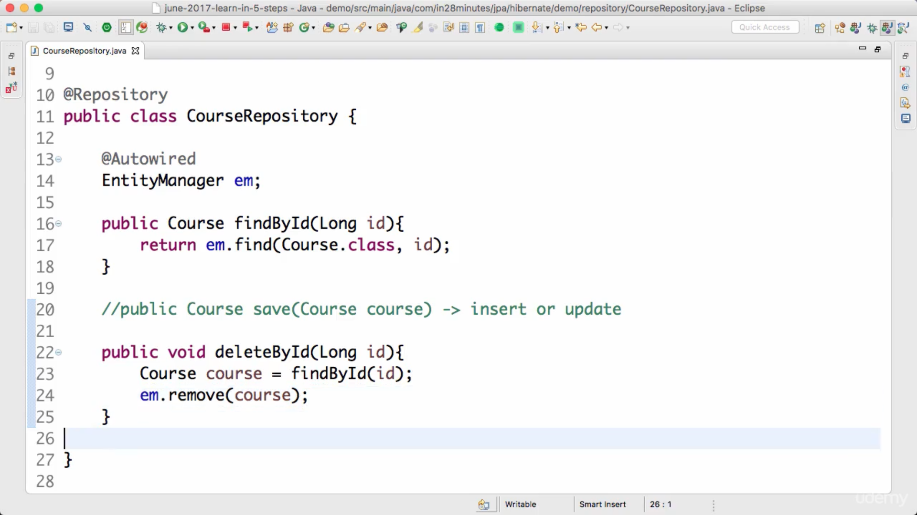

@DirtiesContext : as in unit test we are modifying data, this annotation tells sprint to roll back database state once tests are complted.

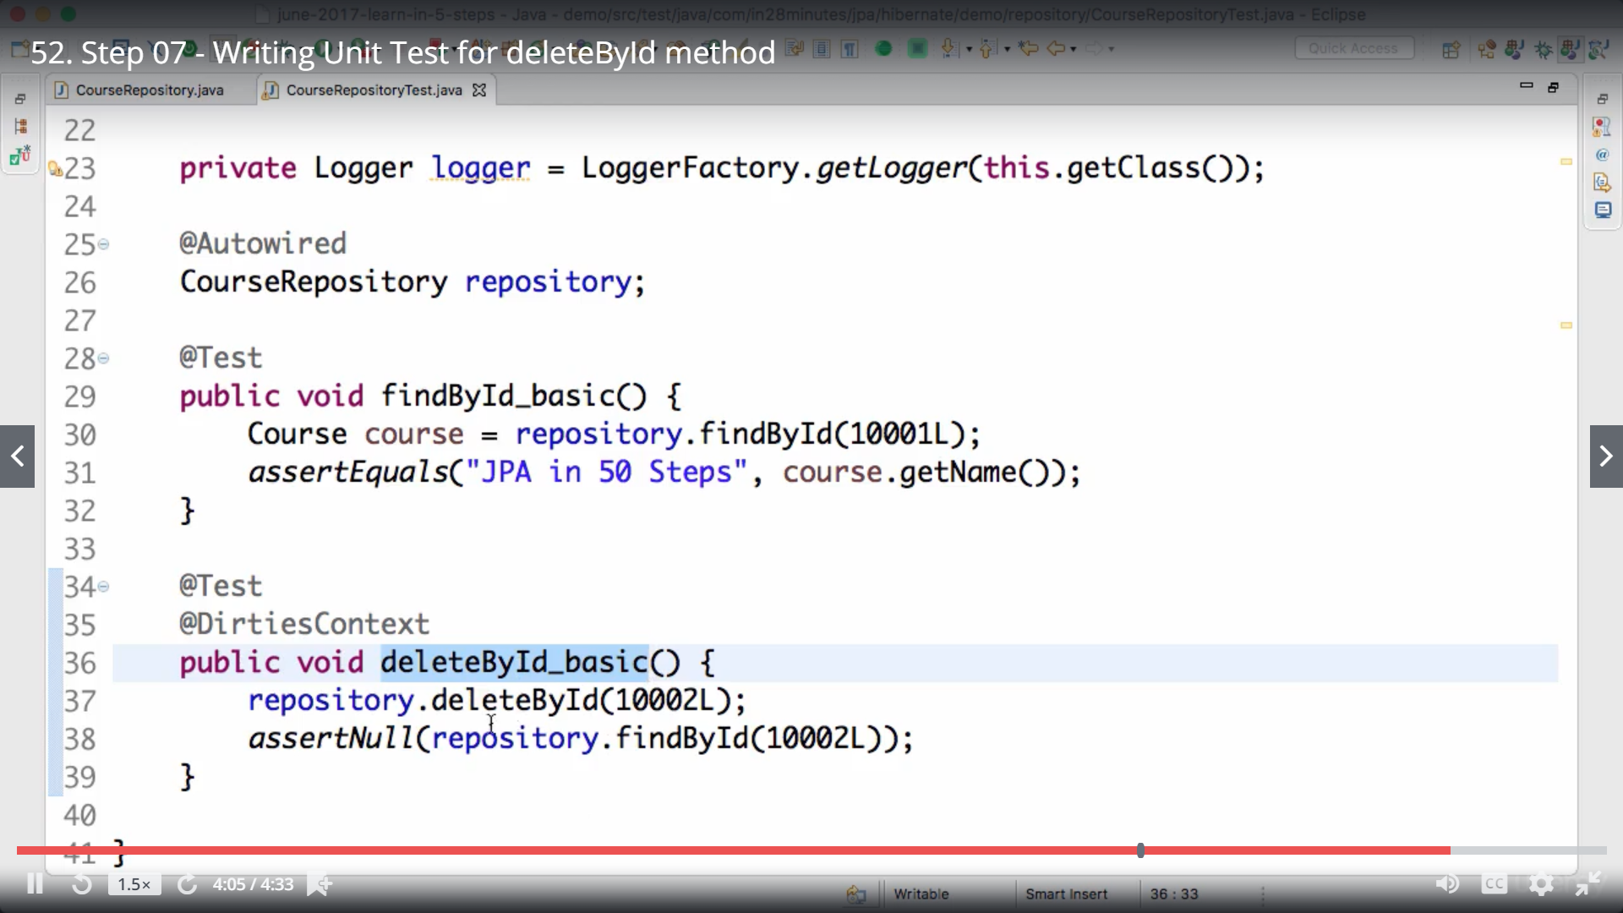

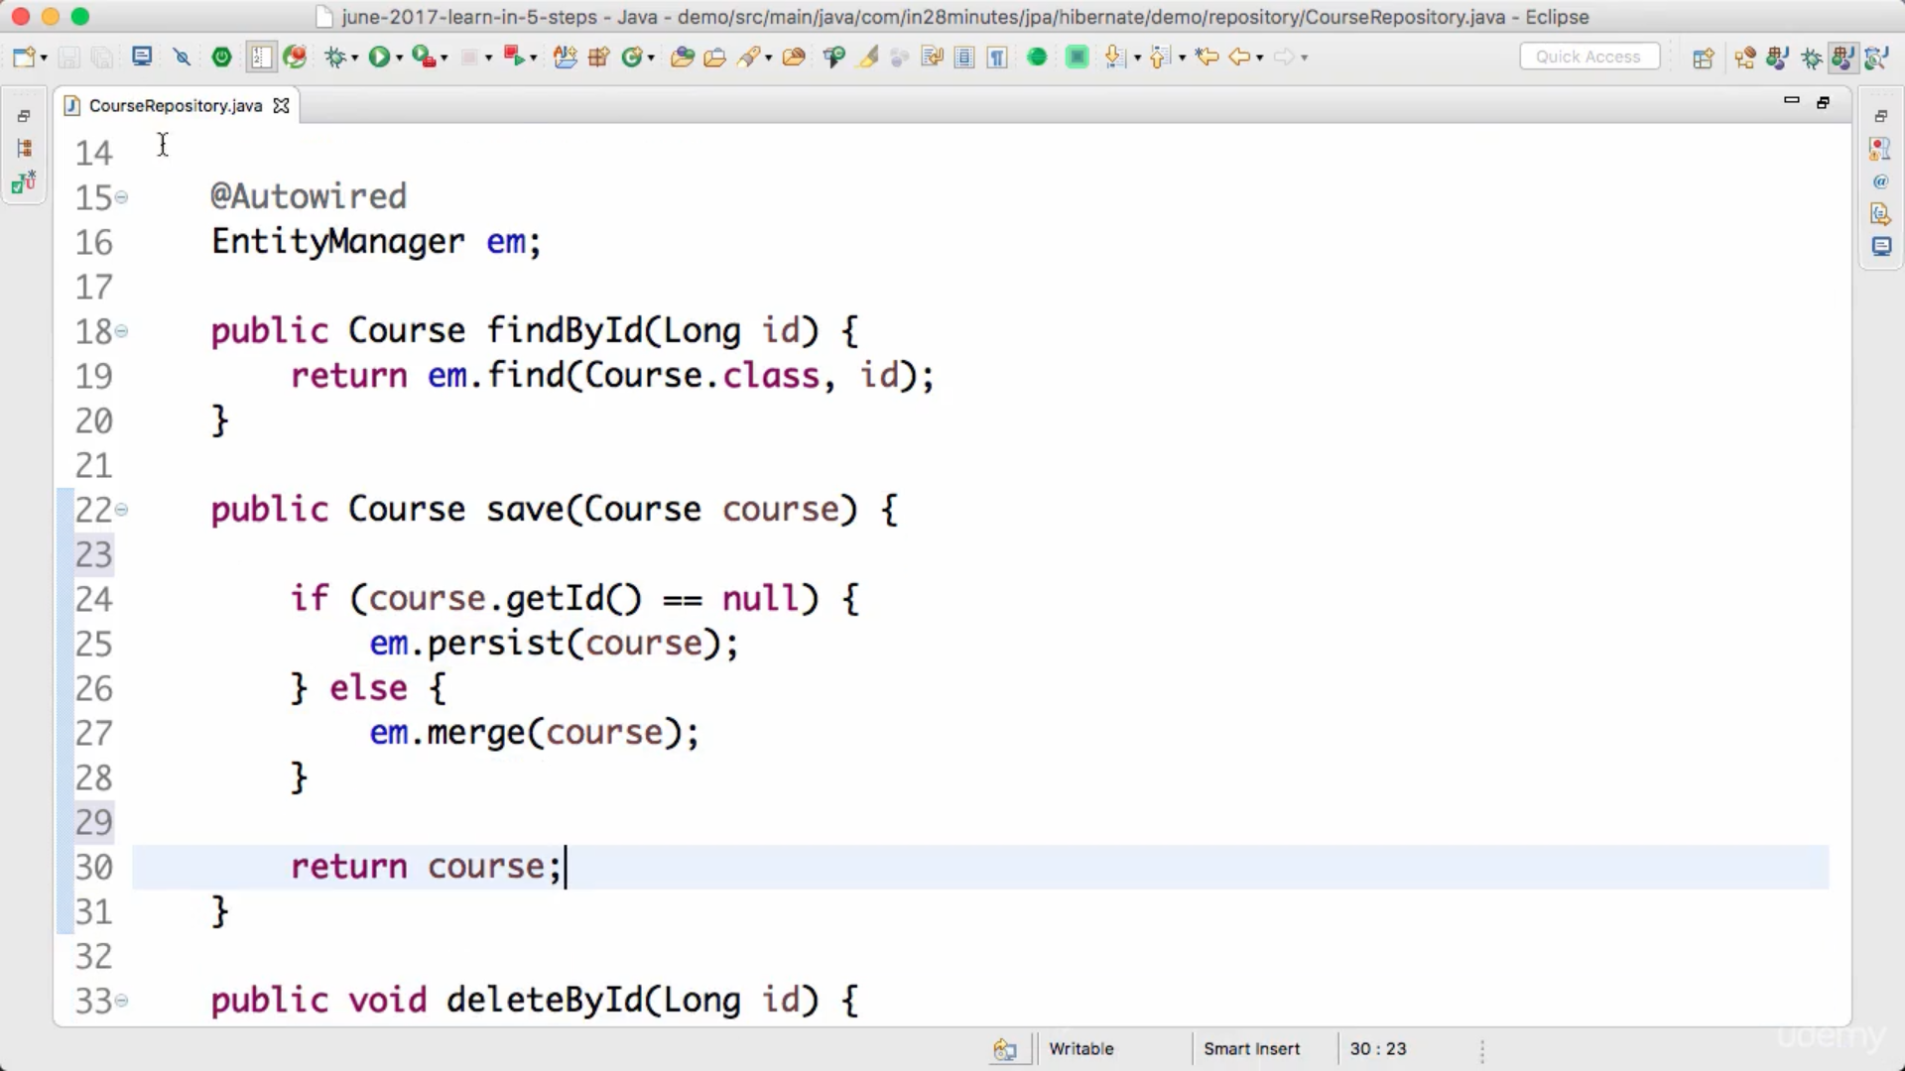

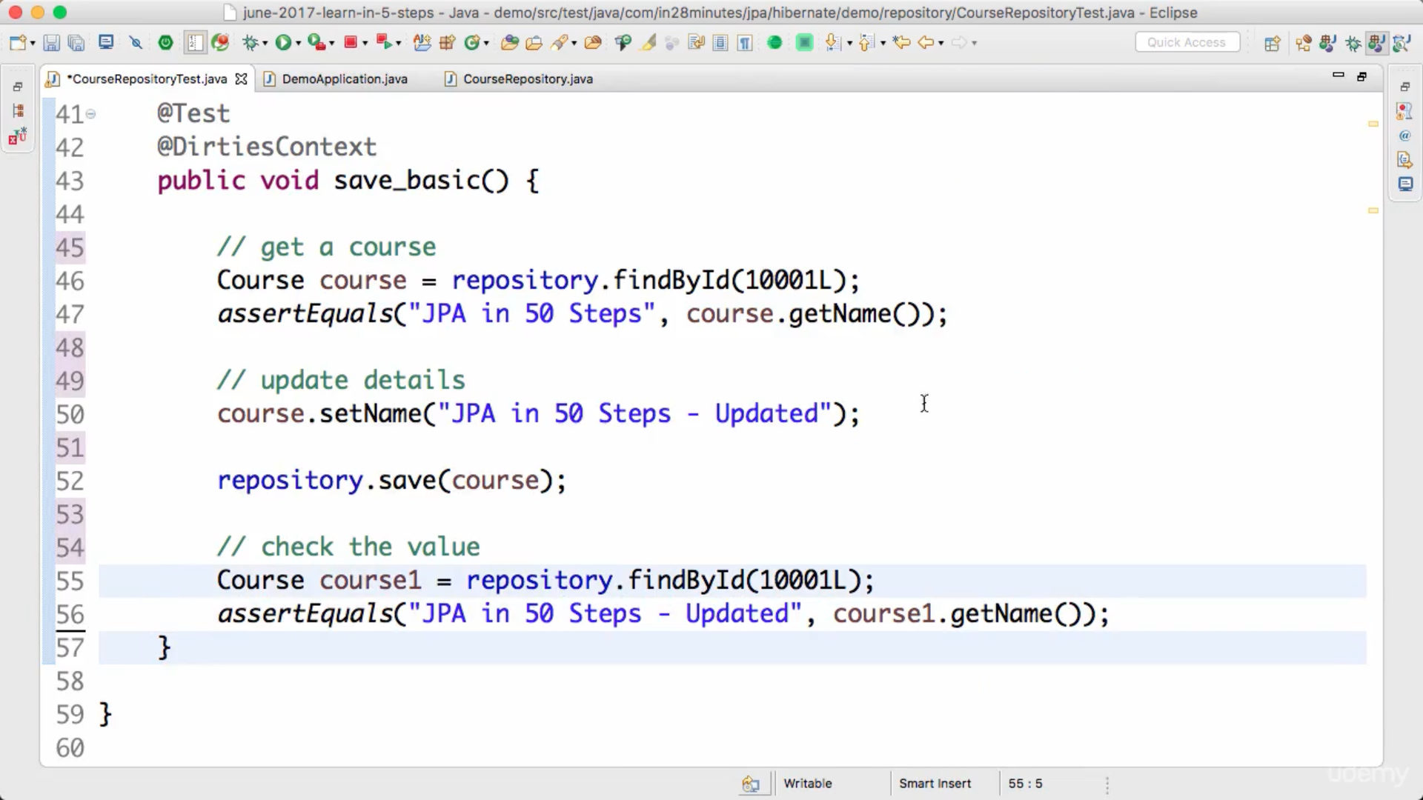

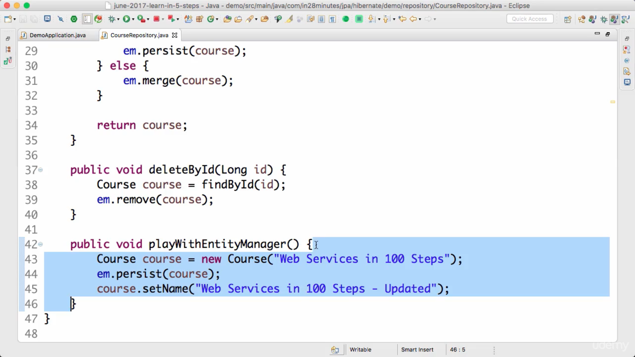

After update we are not explicitly saving updated course with entity manager, but still it will be saved because entire method is running in transaction. At end of method it will commit data and entity manager is tracking course instance.

Em.flush() : will send updates to database.

Em.detach(<entity>) : it will remove entity from entity manager and it will stop tracking it.

em.clear() : this will detach all entities from entity manager.

Em.refresh(<entity>) : Any unsaved updated to entity will be lost, entity will be loaded from database.

SQL: queries read data from tables “select * from course”

JPQL: java persistence query language reads data from entities i.e. “select c from course c”

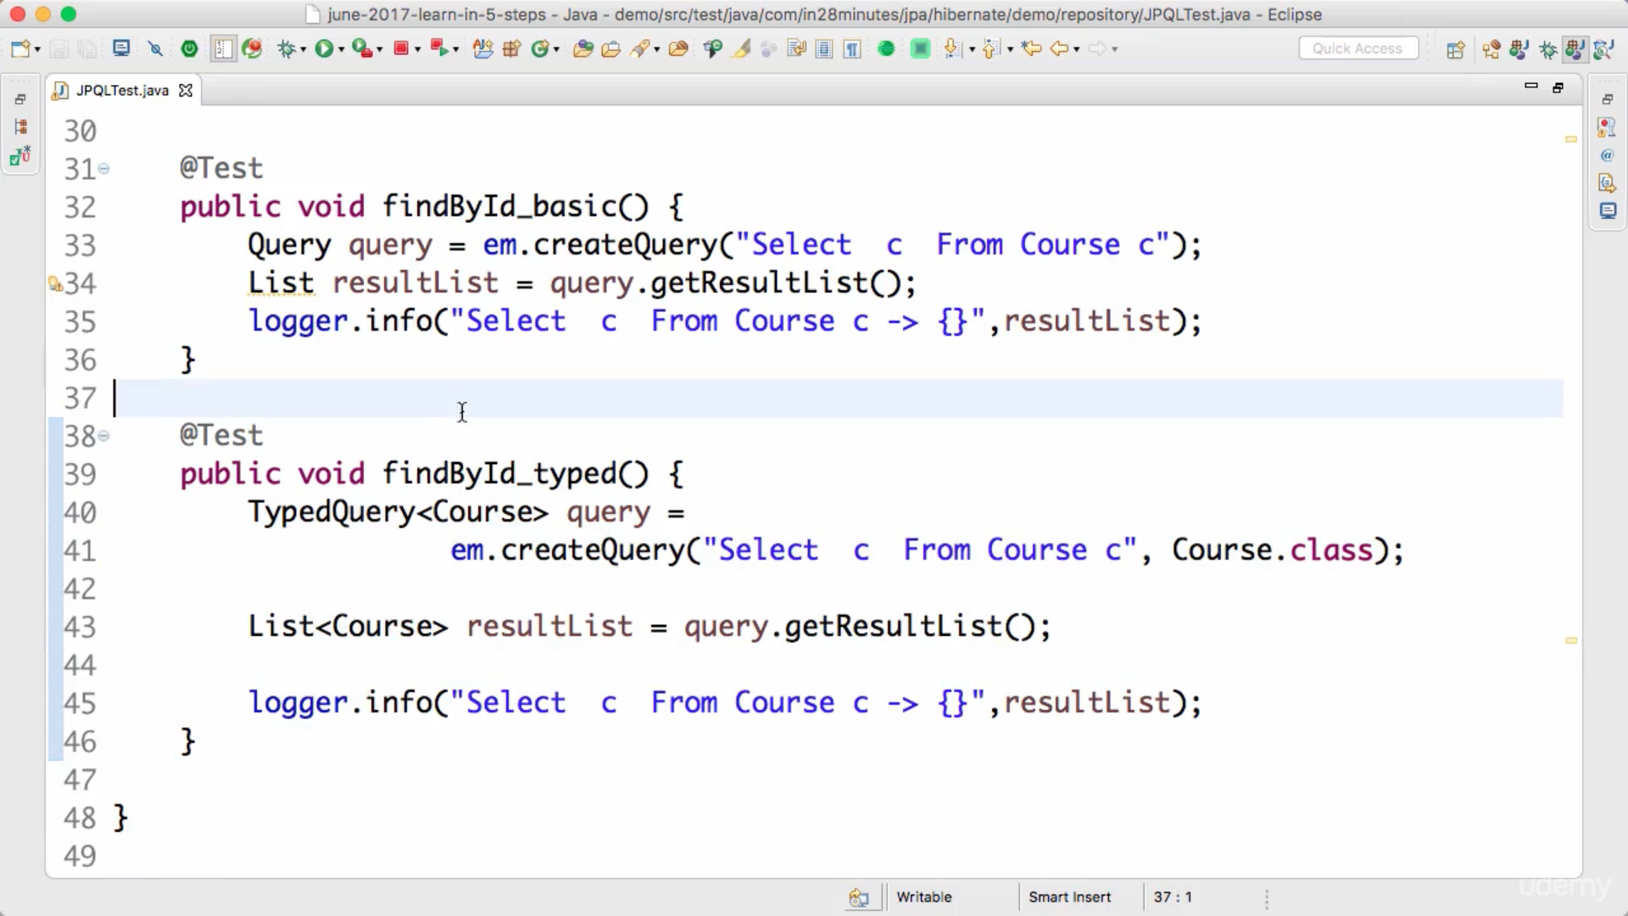

If the name of entity is different than database table name then we can use @Table(name=databasetablename)

@Column(name-databsetablecloumnname, nullable=false) : nullable false means value cannot be null.

@Updatetimestamp & @creationtimestamp are hibernate annotations

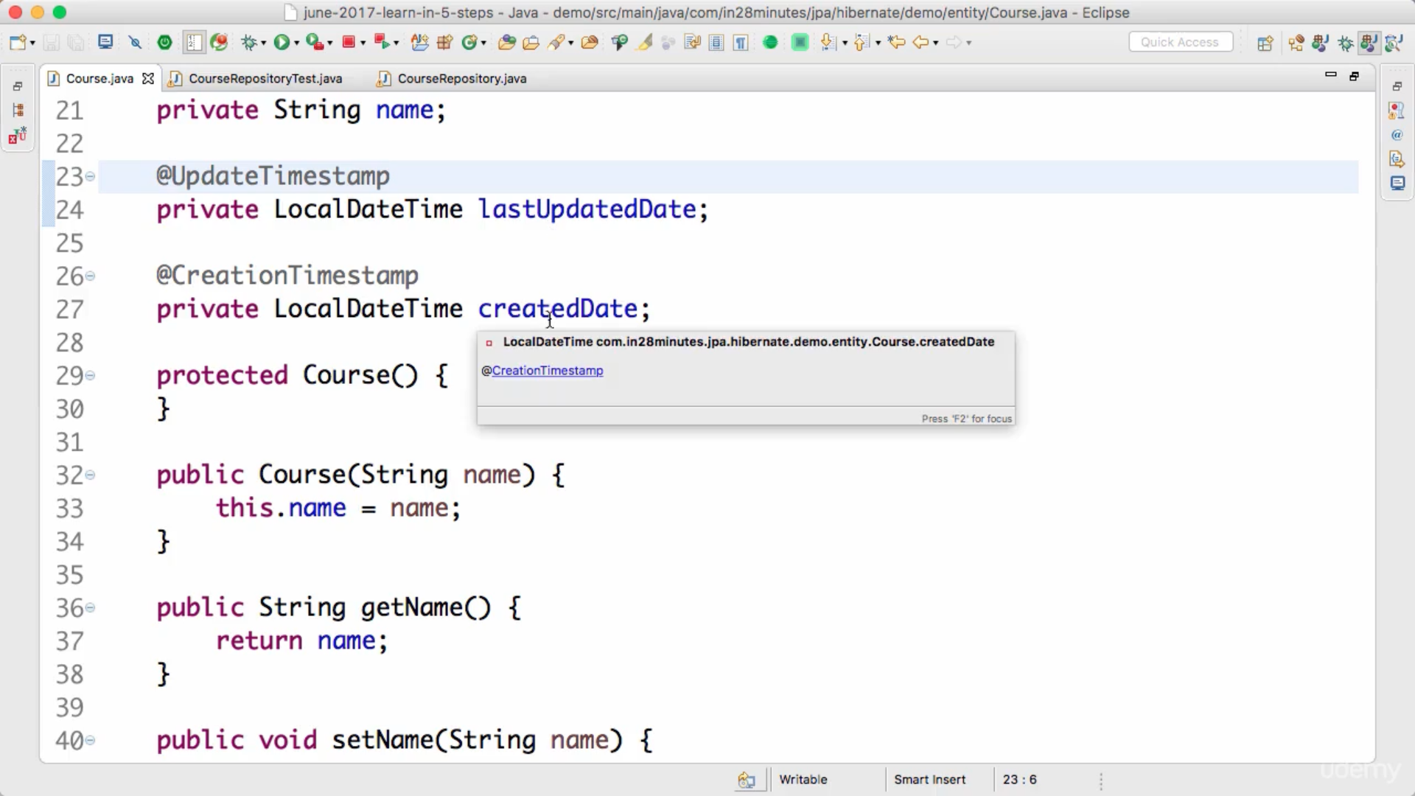

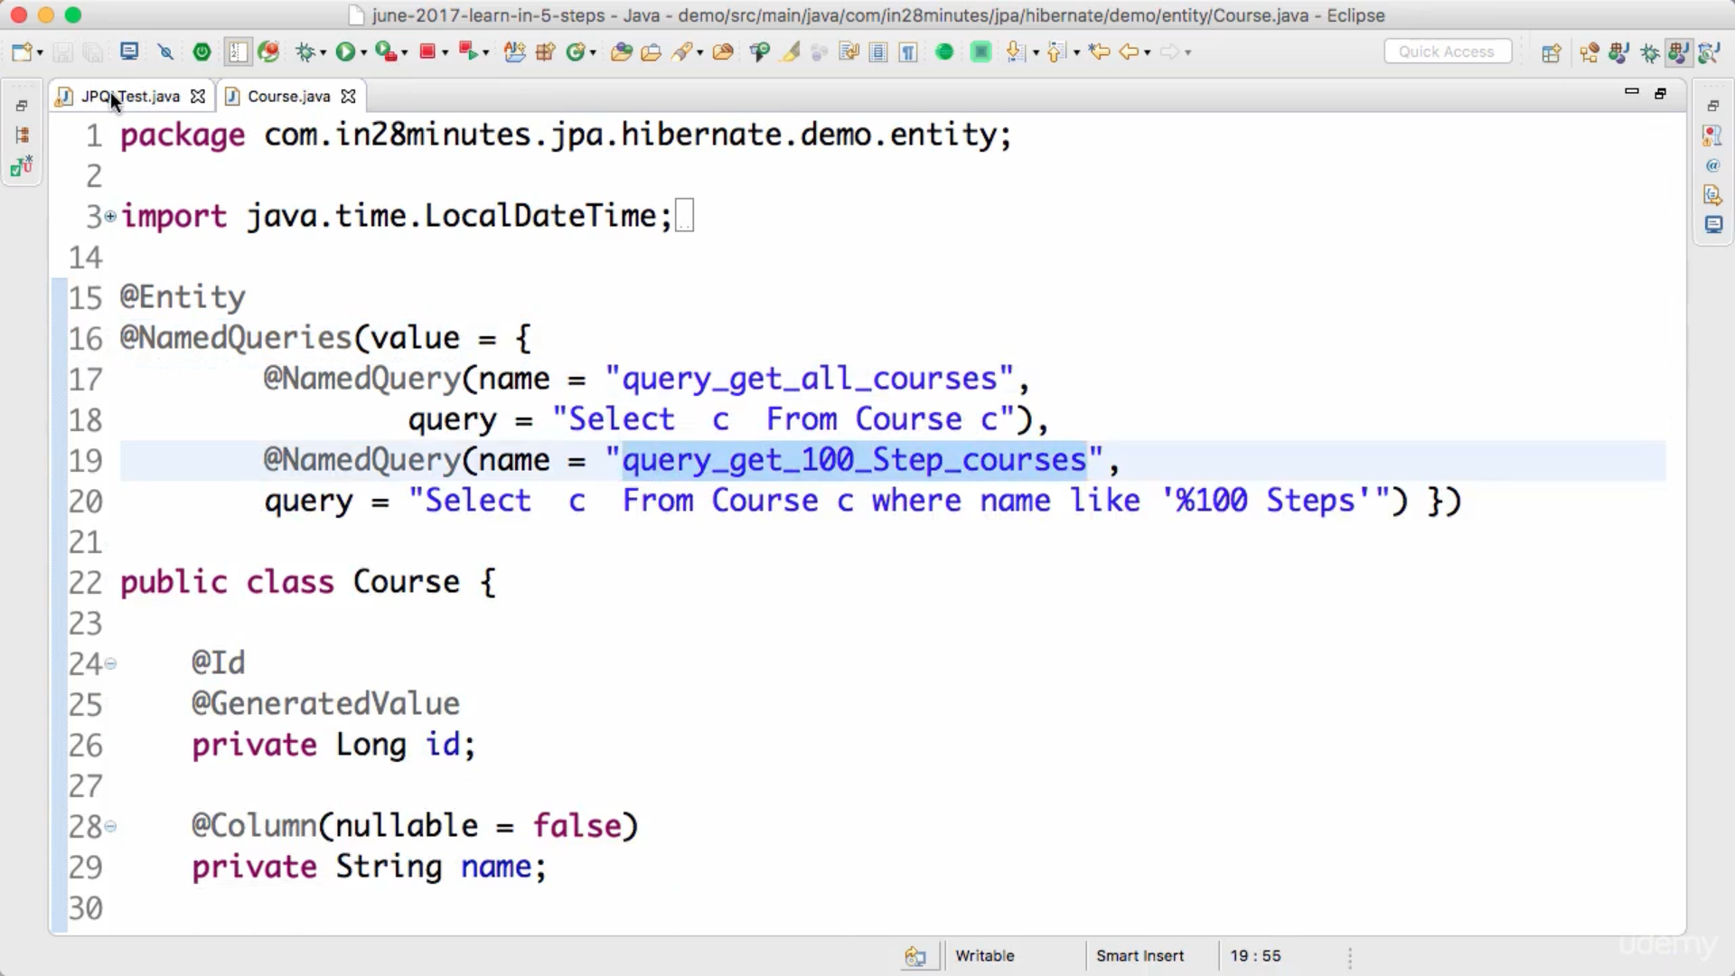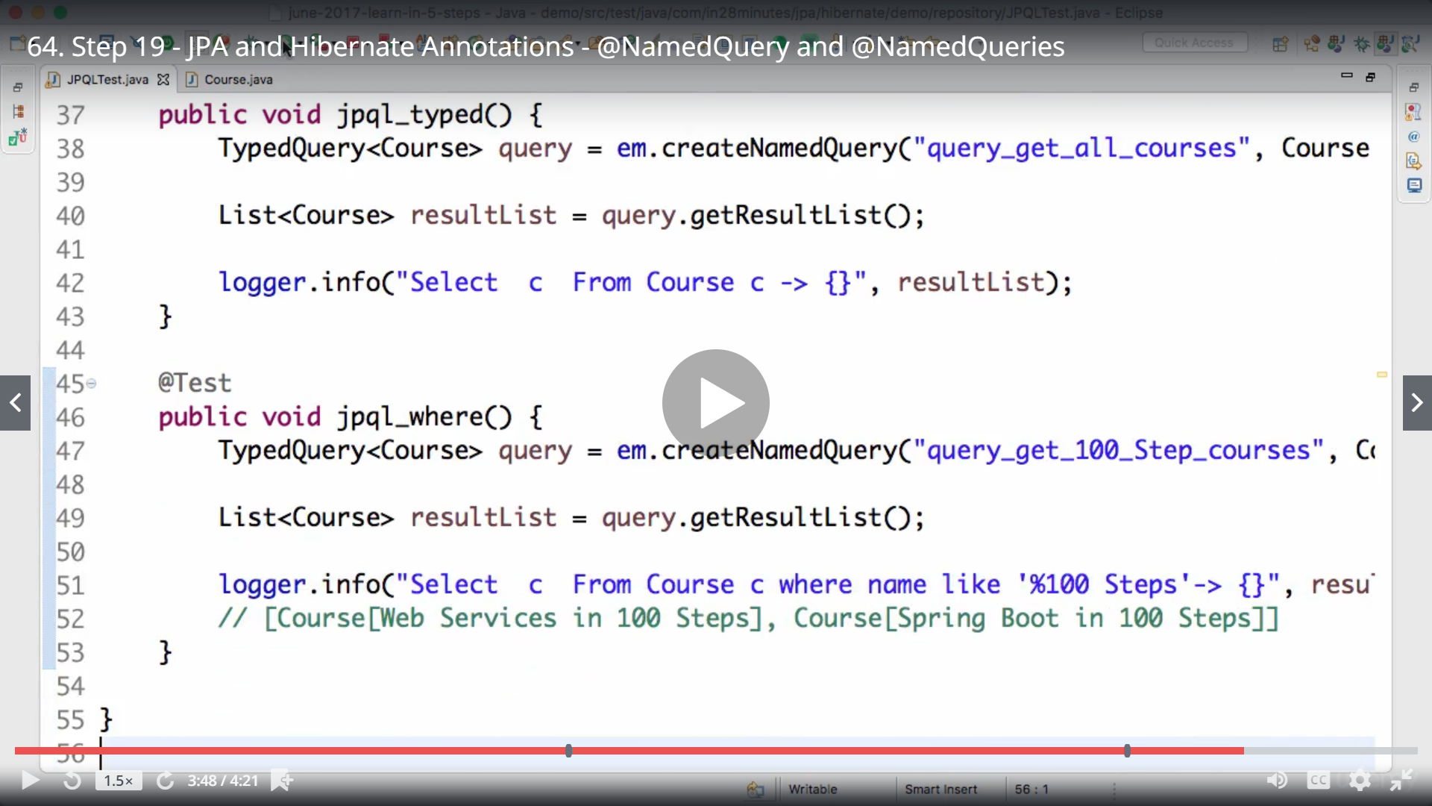

Execute native sql queries,

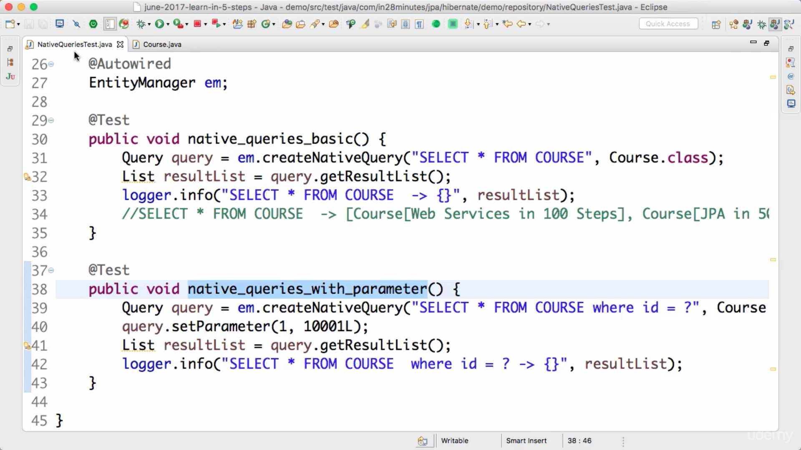

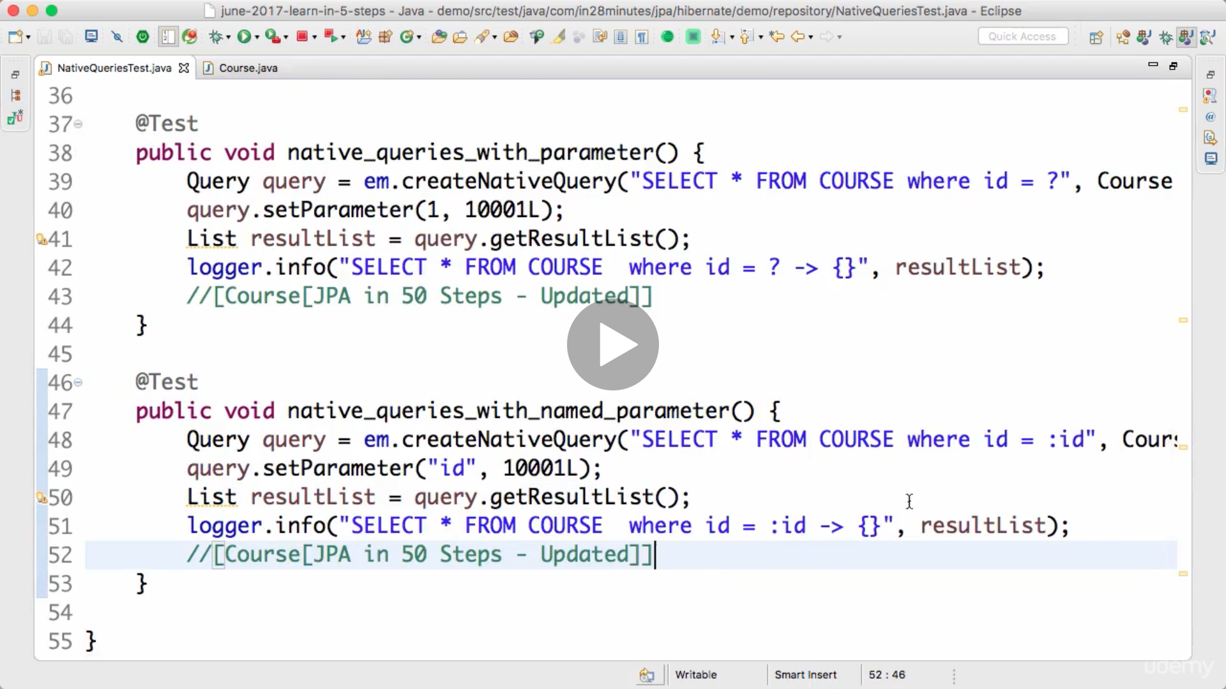

To do mass updates native queries are best because jpql will load entities and then update.

Mappings : create basic entities and tables for student, passport, review.

One to one mapping: we can simply add primary key of as column in student table to have passport ids, or vice versa, whoever have column as foreign key that is known an owning the relationship.

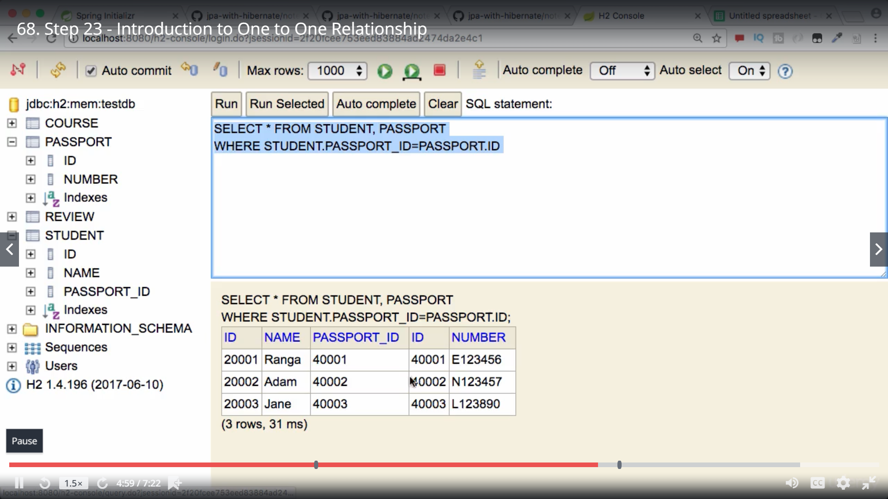

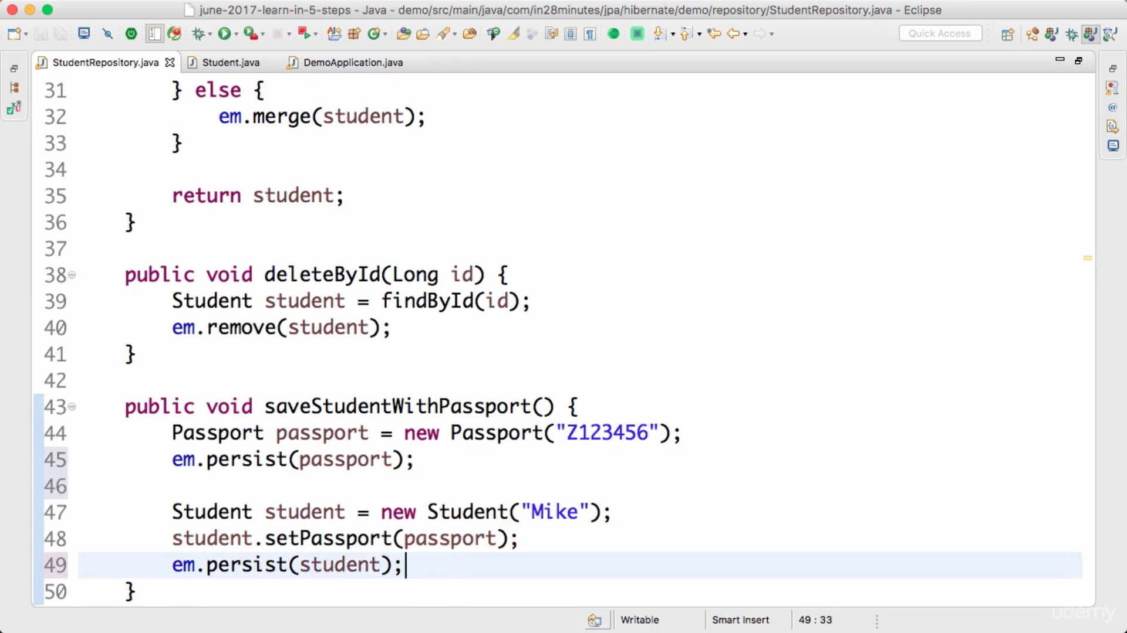

Hibernate is lazy, it will wait until it fixes updated to database maximum to transaction completion.

Define passport in course entity and add @onetoone annotation over it to define mapping.

@OnetoOne is by default eager fetching, mapped details are retrived with main entity.

But for sake of performance we may need to load mappings in lazy mode as we don’t know if they will be required or not, fetch whenever required.

So update @OnetoOne(fetch=FetchType.LAZY) : but while retrieving please ensure we are running under transaction otherwise em will not keep track or main entity and whenever we will fetch mapped data it will throw error no session. Transaction internally opens hibernate session.

Terminology Persistence context: this is created whenever a transaction is started, and it lives until transaction is completed. We interact with PC through entity manager. PC tracks all changes in made to entities managed to EM within transaction.

UNIDIRECTIONAL/BIDIRECTIONAL OneToOne Mappings

IF we define mapped entity is main entity like below, right now student is owner who will maintain relation in database. If we fetch student we can fetch passport details as well. This is Unidirectional.

In Student Entity.

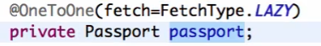

But if we want to retrieve passport and want to retrieve student from retrieved passport entity, its not possible. To fix this we need to make it bidirectional by defining reference of student in passport entity.

In Passport Entity.

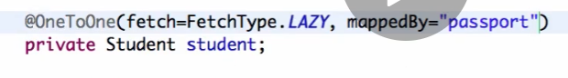

But now both tables will have foreign key to other mapped entity, which is violation of database standards as we are storing redundant information. We again want to make one of then entities owner, this can be achieved by adding **mappedby=”Variable name of this entity referenced in owner/other entity” , we don’t modify mappings at owner side, like not modifying in student. But modify other entity like passport and here defines how passport is managed at owner side.**

**ManyToOne Mappings**

Here we are taking example of course to review, review will be owner as course cannot maintain foreign key to refer multiple reviews, where as every review is associated with 1 course so it can hold reference to course.

One course can hold multiple reviews so defined OnetoMany relationship, defined list to hold multiple reviews and we need to create instance of list.

While defining getters and setters for reviews, we don’t need setter as no one is going to set multiple reviews in single call, where as we need add and remove methods to add and remove reviews from course.

And we will be adding referenced by in course because owner is review entity , so add variable name define in review to map course which is “course.”

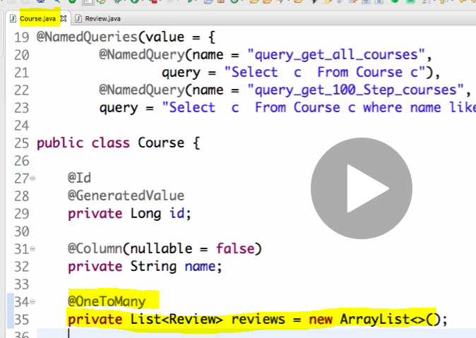

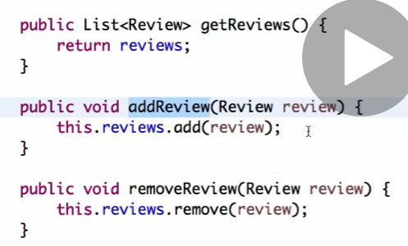

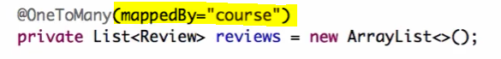

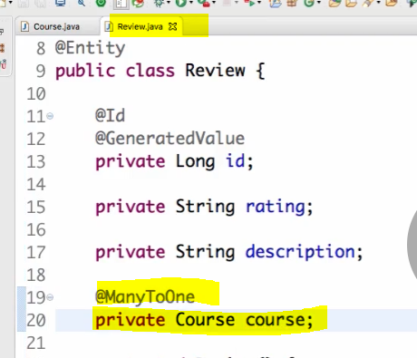

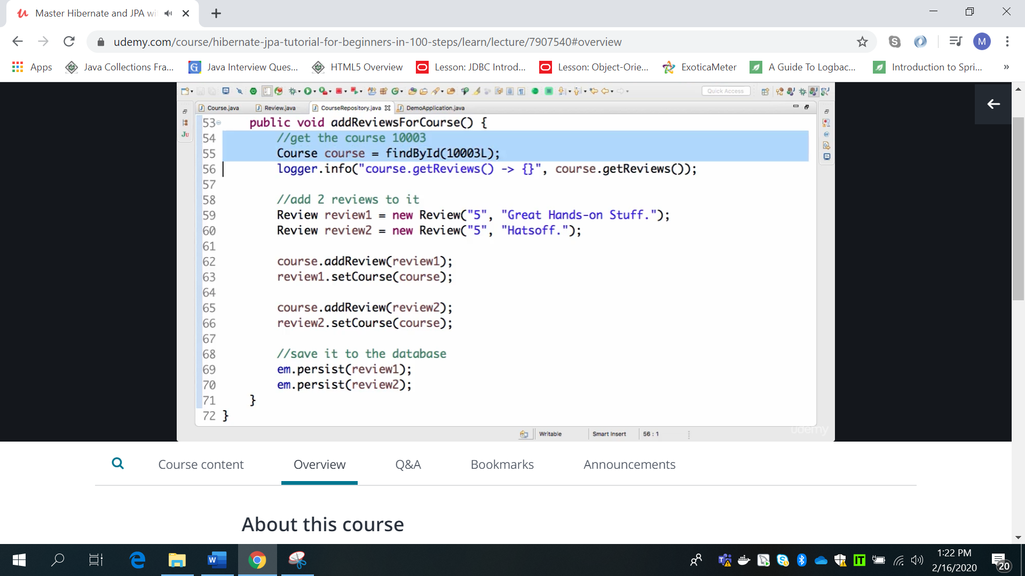

We need to add reviews to course and add course to review and the just persist reviews.

Refactor code

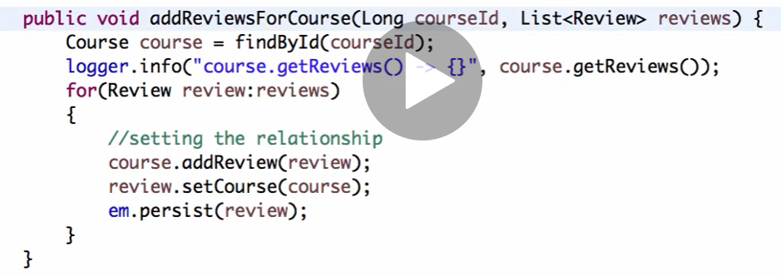

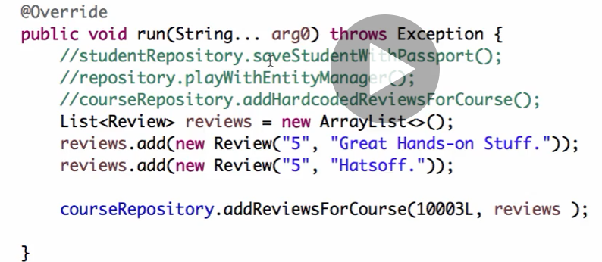

By default fetch type is lazy in onetomany mappings, data will be fetched when required and that too in persistence context otherwise no session error. We can make it eager

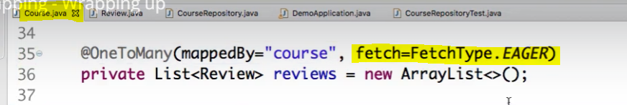

In case of manytoone, means when we retrieve review it will fetch course as well because ManytoOne is by default eager.

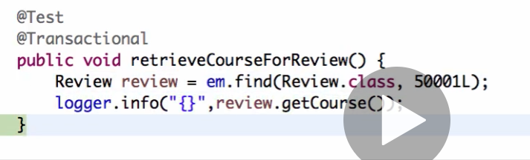

**ToMany : Always lazy by default

**ToOne: Always eager by default.

**MAnyToMany Relationshsips**

Course can have many students, students can have many courses, we will introduce join table tohold relationships in database.

In course entity : remember to add methods to add and remove students instead of setter of students.

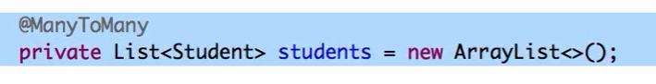

In Student entity: remember to add remove methods for course, instead setter of course.

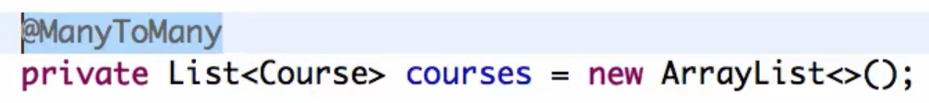

But this will crate 2 join tables, course_students & students_course.

In Course entity.

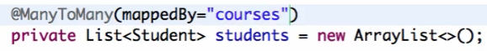

We need to define owning side for mapping, we defined student as owning side hence added mapped by in course entity.

Student_course join table will be created.

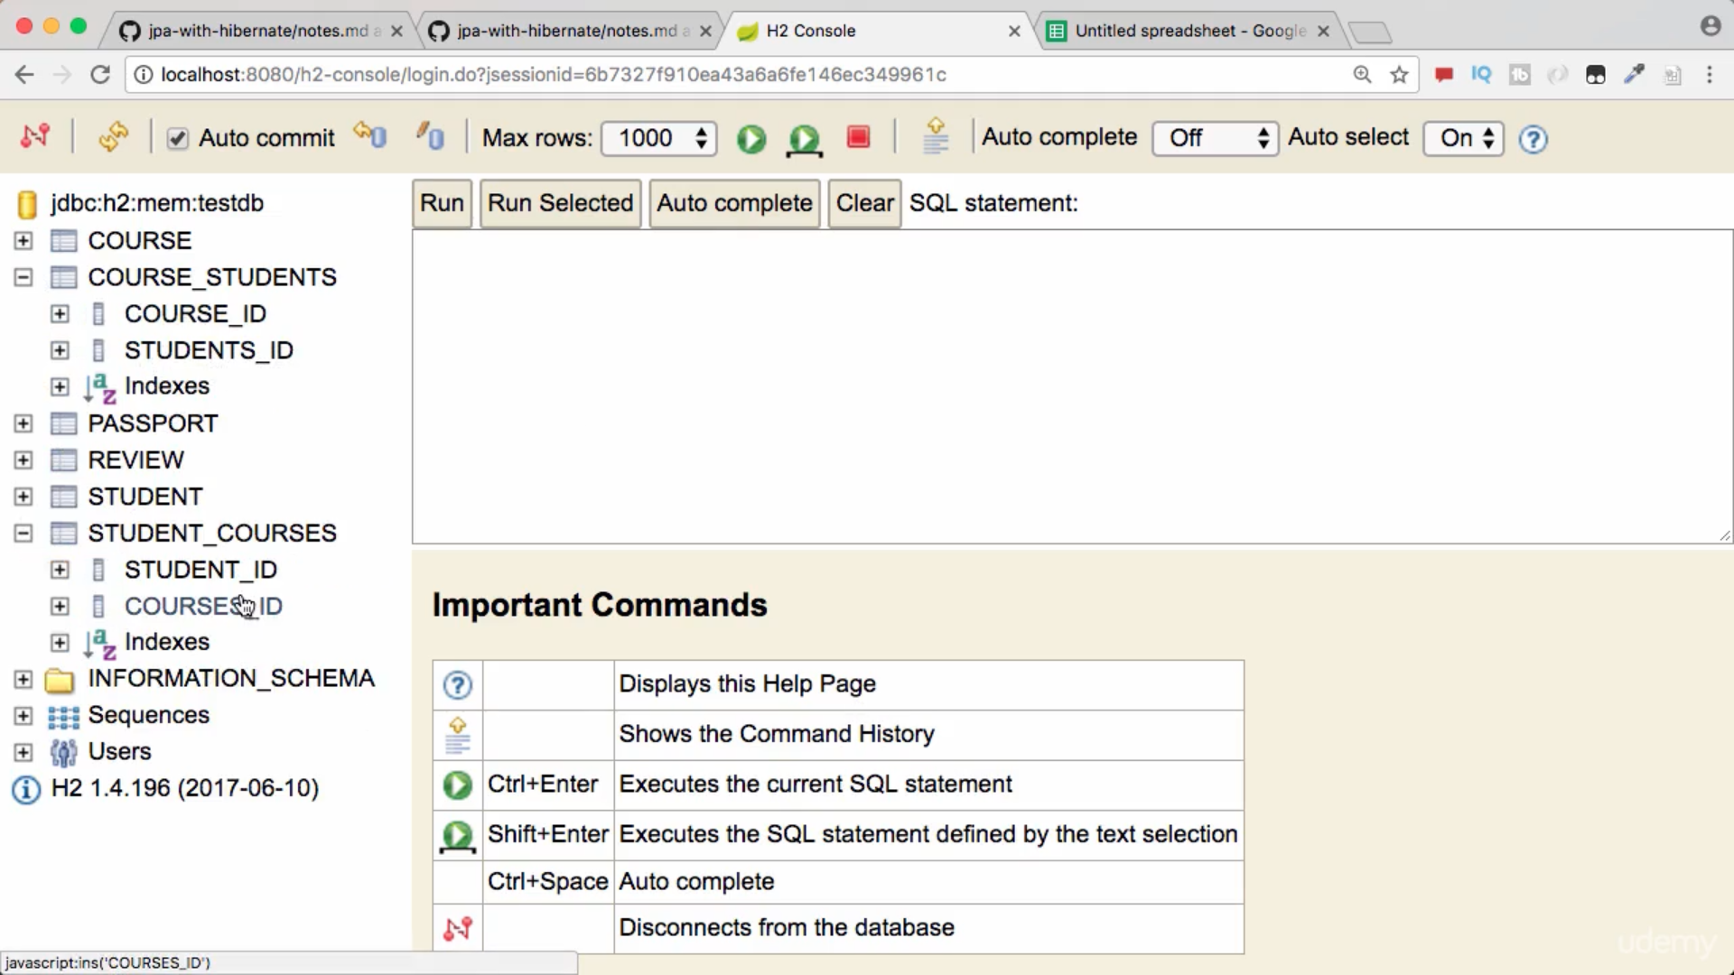

To customize join table , go to owning entity student and update mappings,

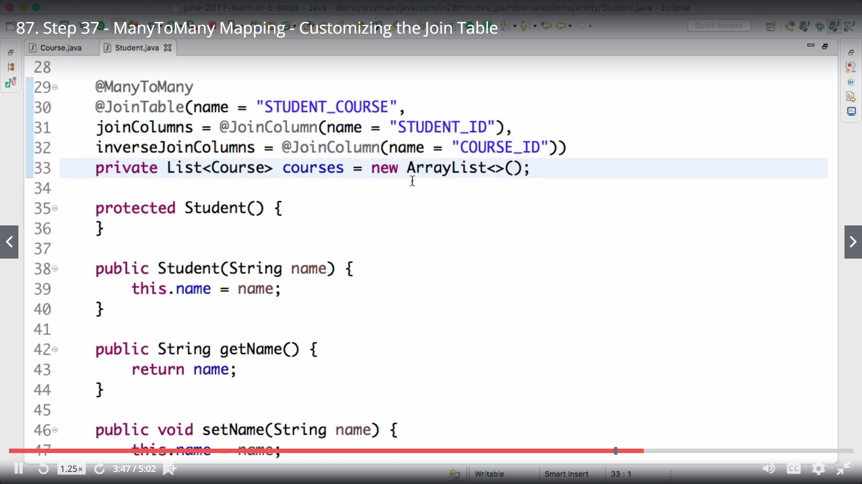

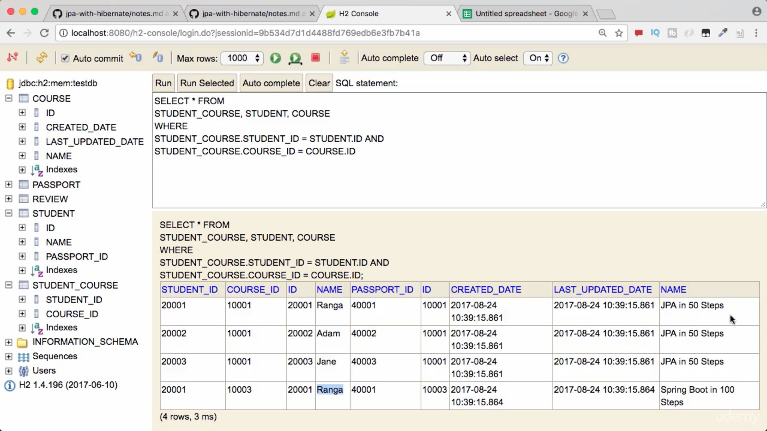

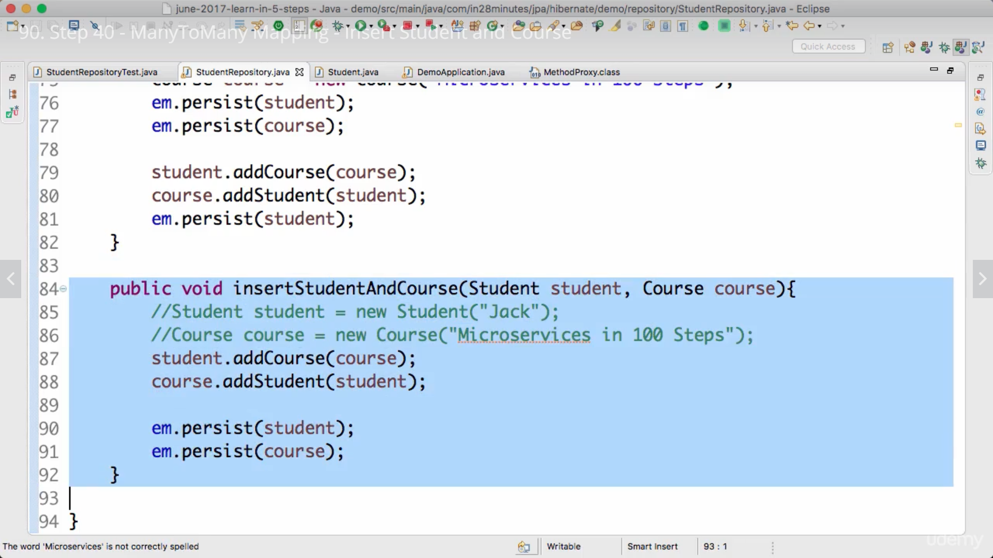

Both side mapping need t be updated like update course in student and student tin course and then save both entities.

If master entities are already saved and we updated mappings only, we are required to minimum persist owner entity.

**Inheritance relationships**

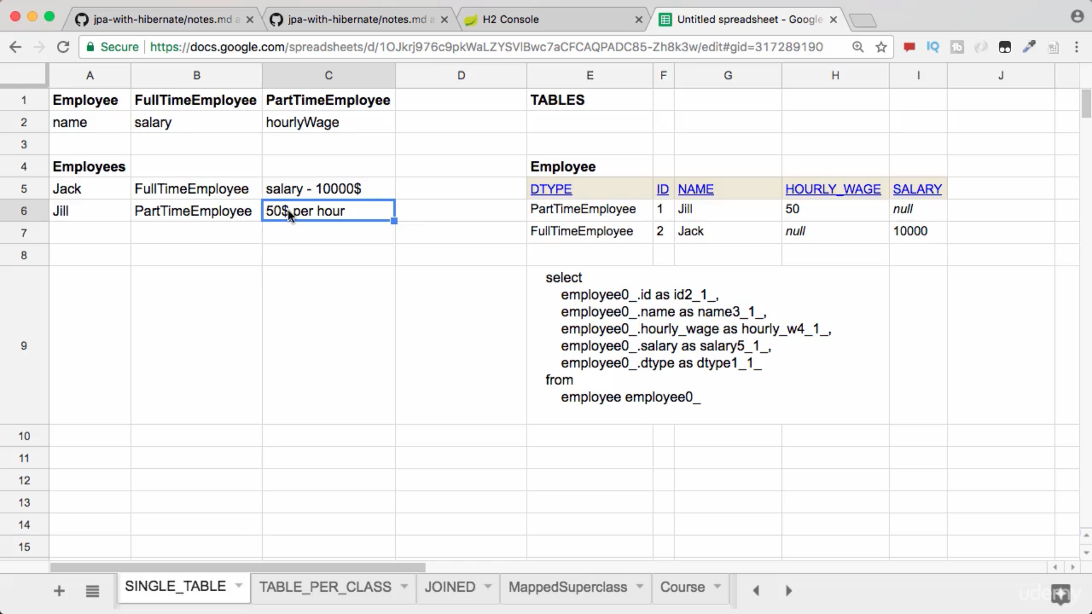

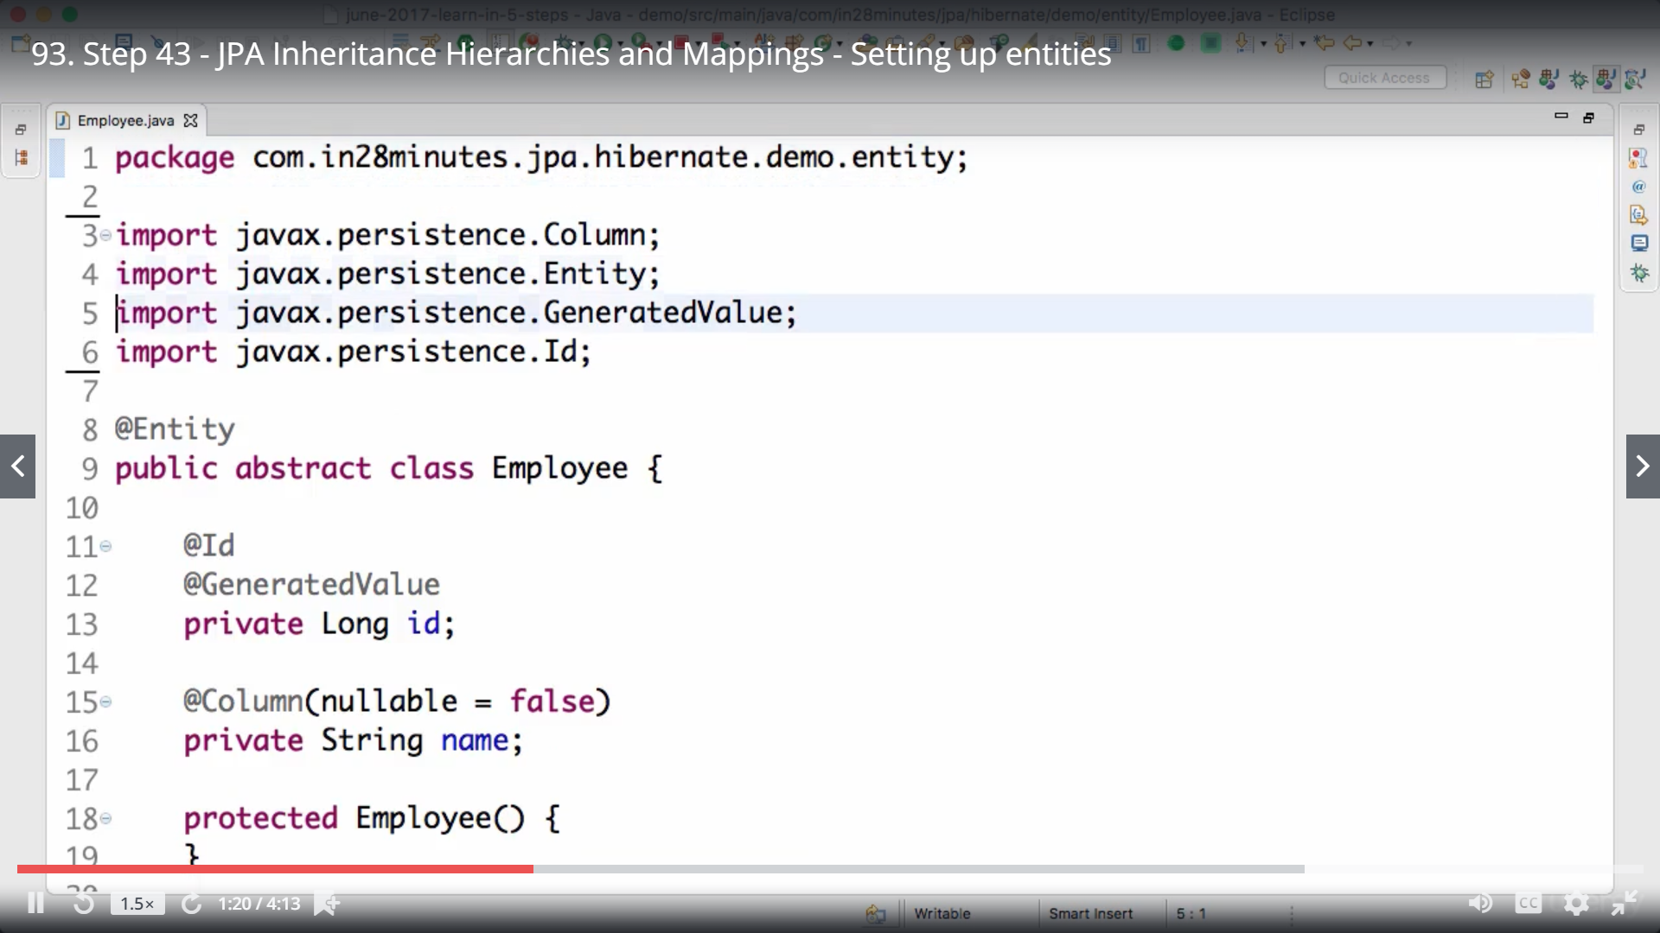

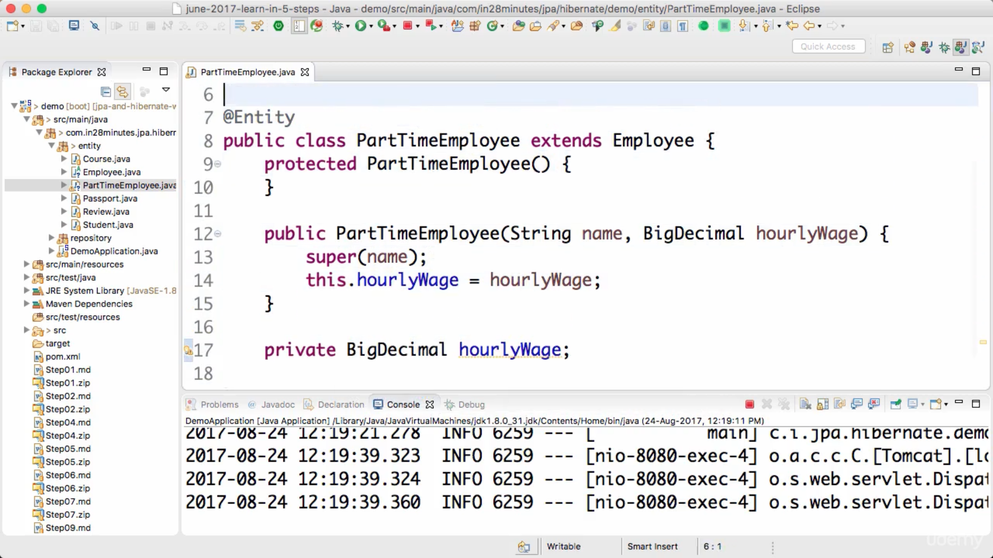

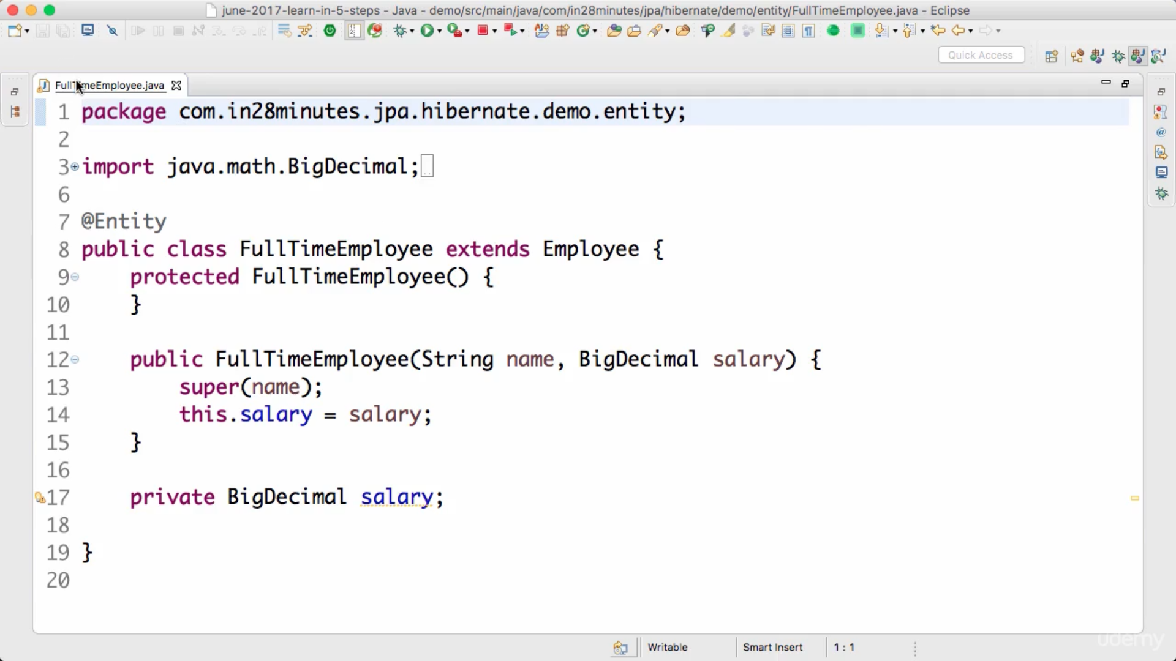

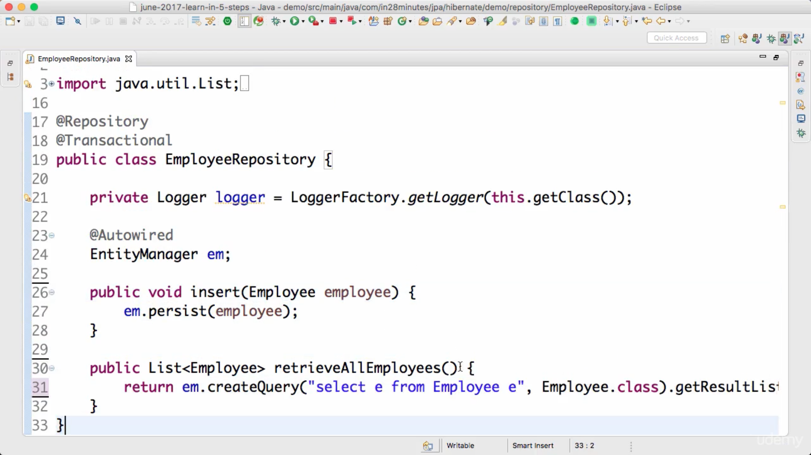

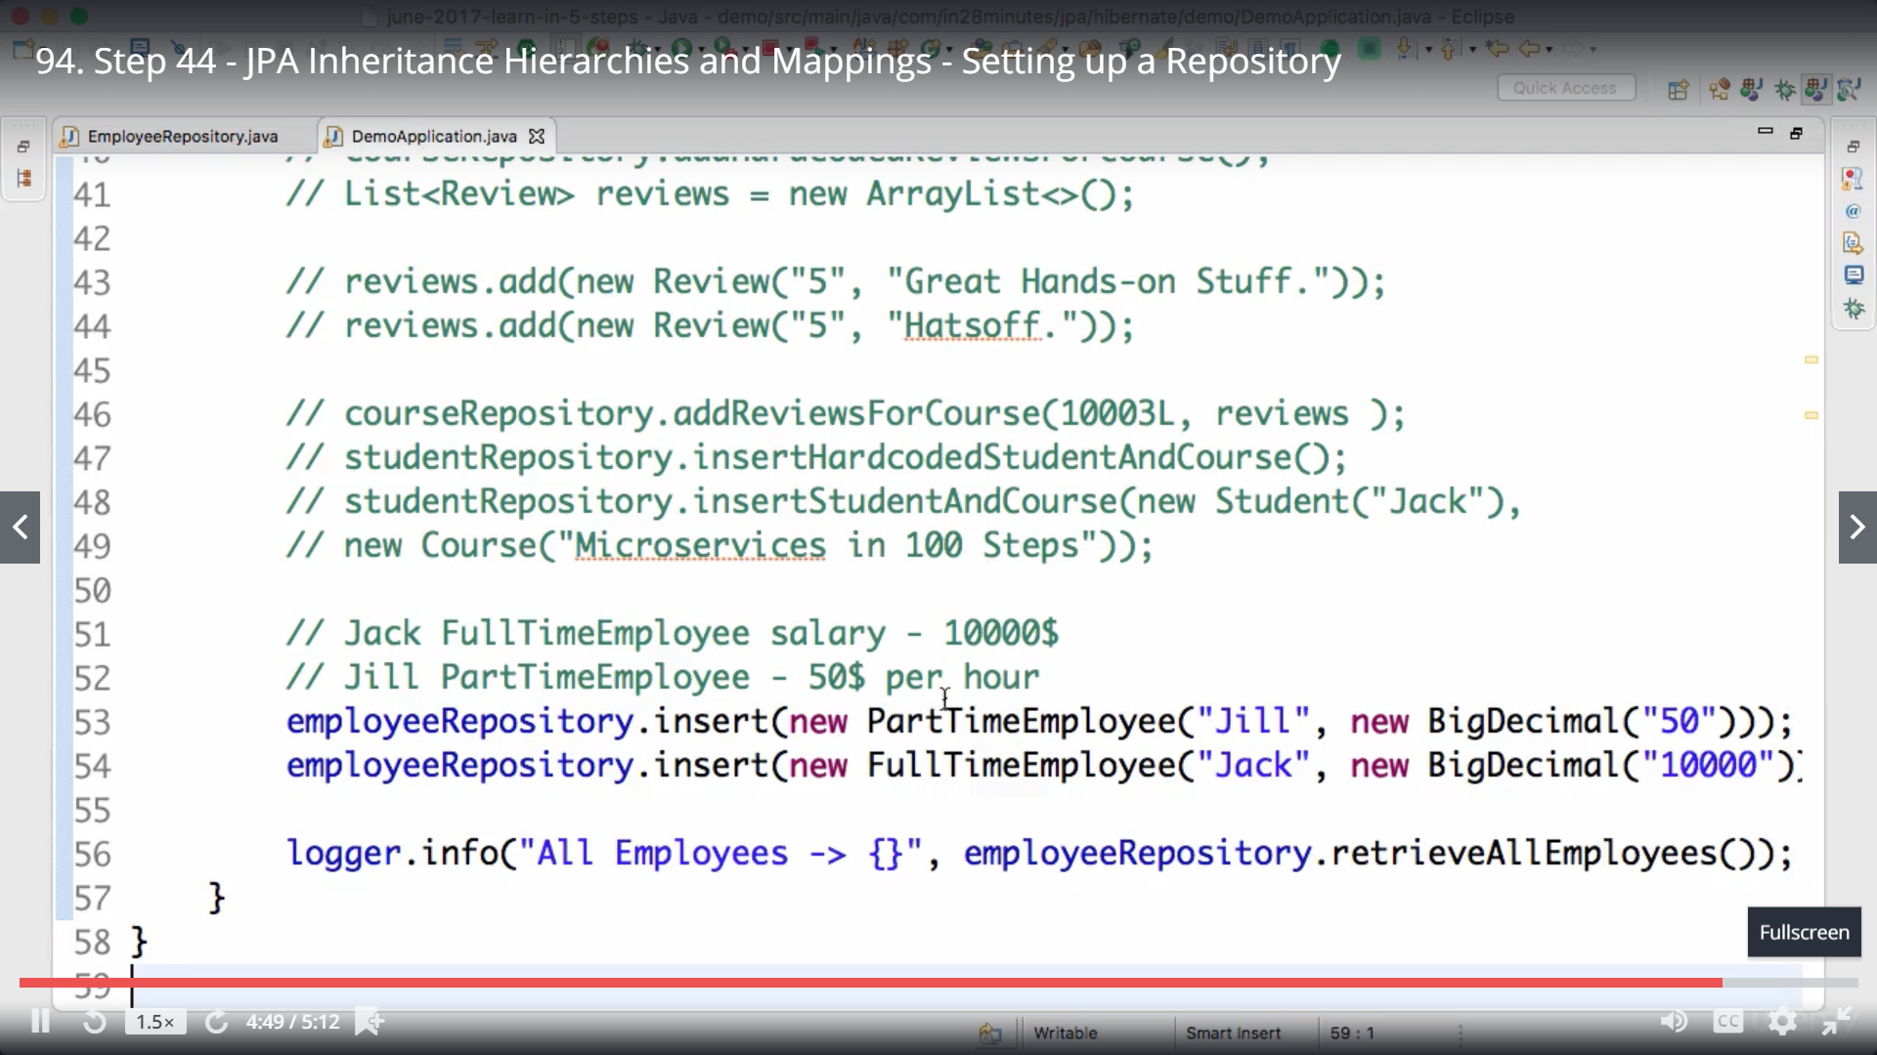

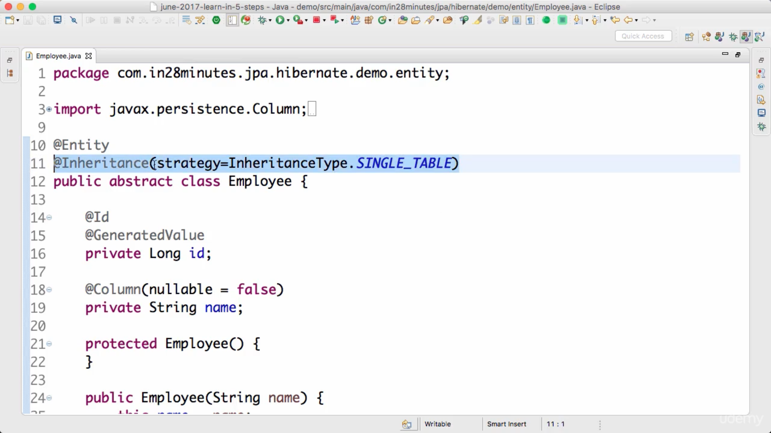

Performance is fast with single table but database perspective lot of null columns.

Default column is there in employ which is dtype-distinguisher type, which holds which subclass type data is stored in this row. We can rename this columns.

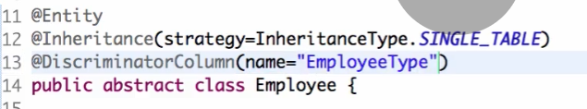

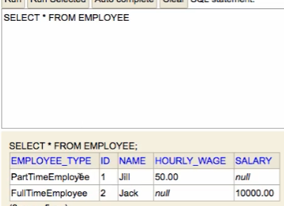

Table per class, table per concrete implementation class, no table for parent abstract class which is employee, even @discriminatorcolumn is not required now as we have separate tables.

Common columns are stored in both tables.

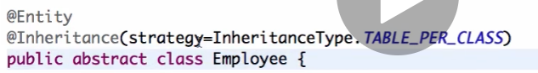

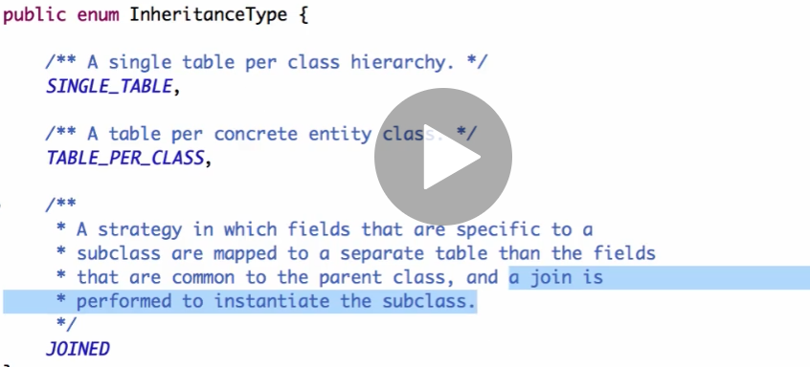

With joined, super class and all subclass tables will be created and join will be performed by JAP to fetch data. Performance is not good because of joins.

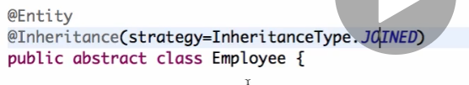

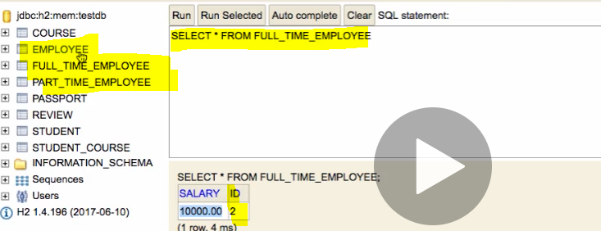

Here id is working as primary and foreign key both, foreign key to fetch data from employee table.

**Another option is not to no use @inheritance, rather use @mappedsuperclass**

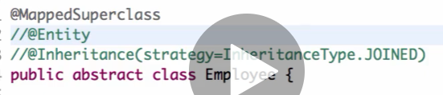

Database perspective there is no common table or class which is employee, hence we cannot fetch employees as this no more an entity

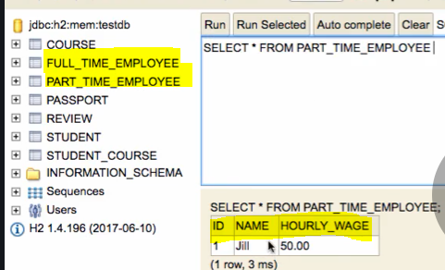

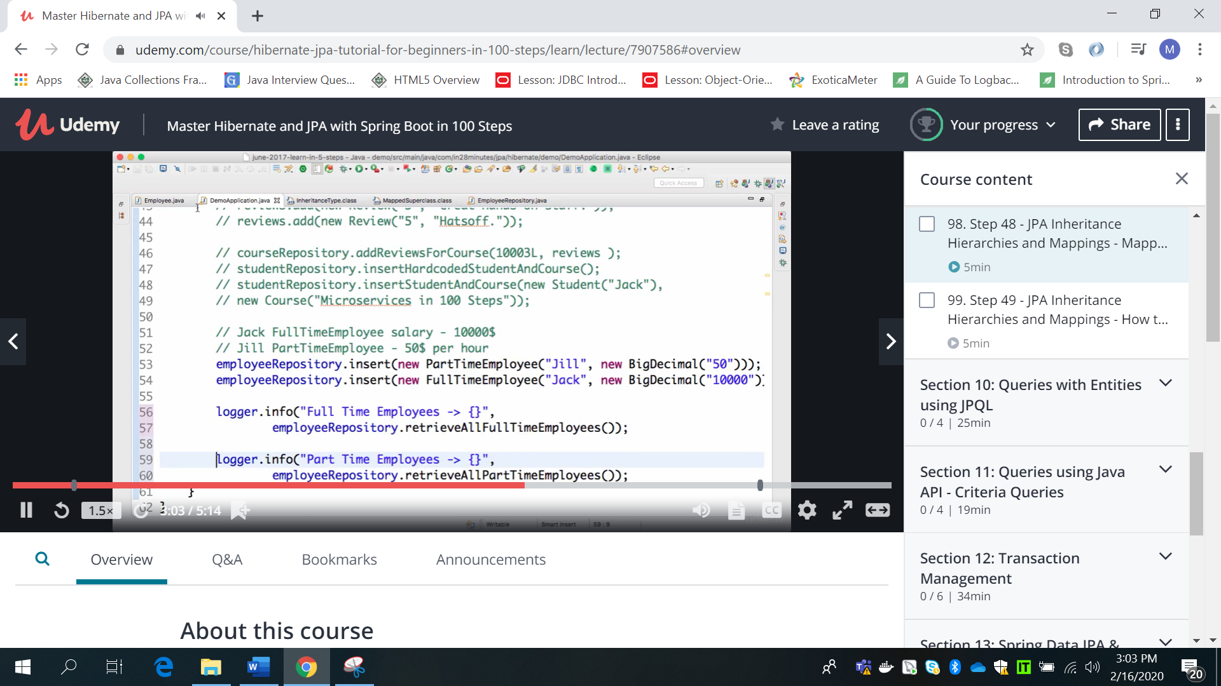

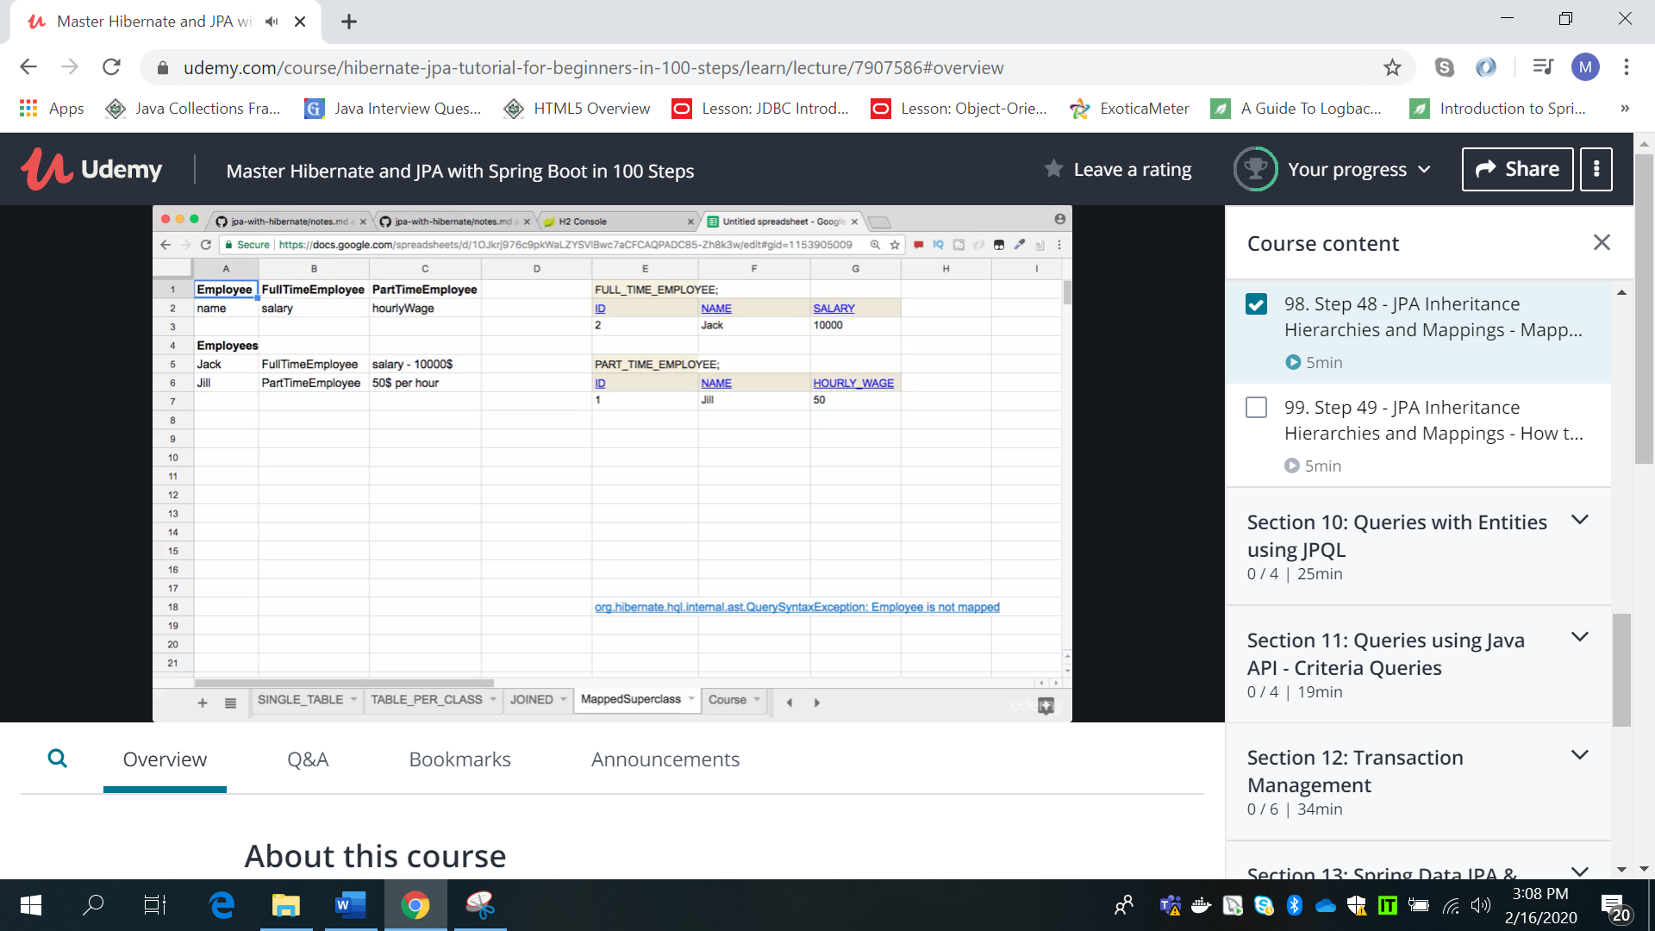

**JPQL**

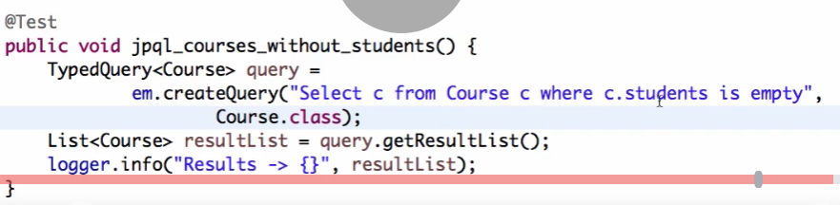







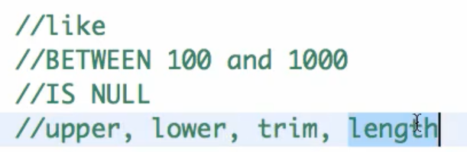

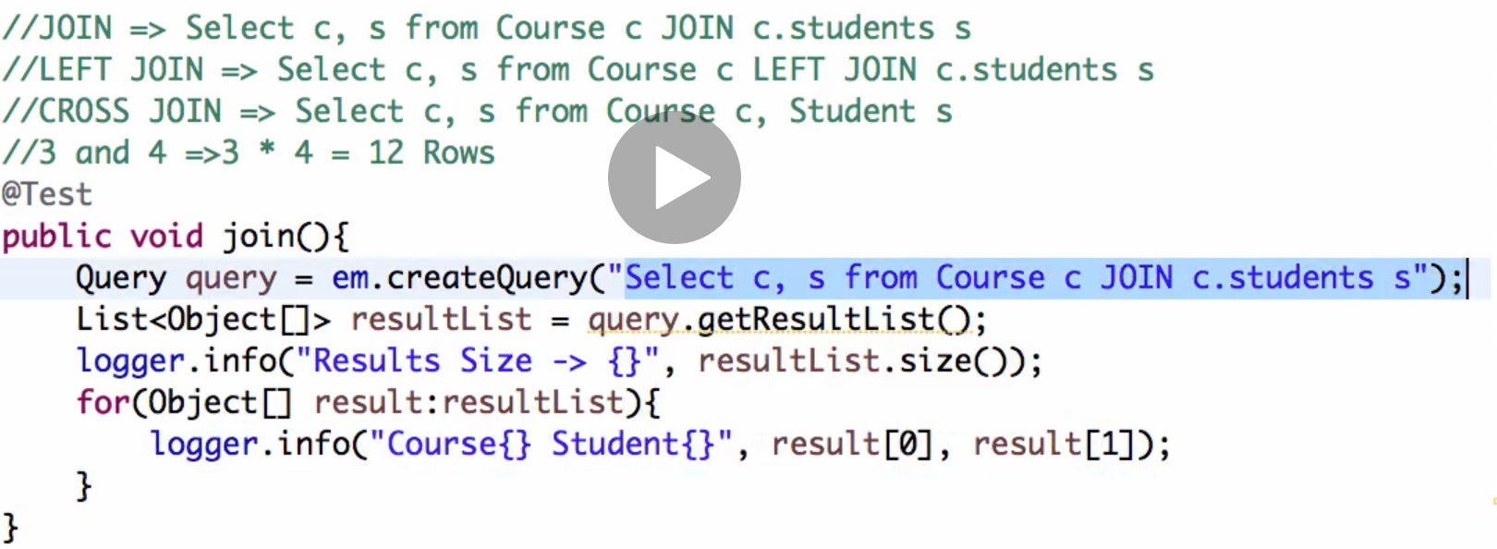

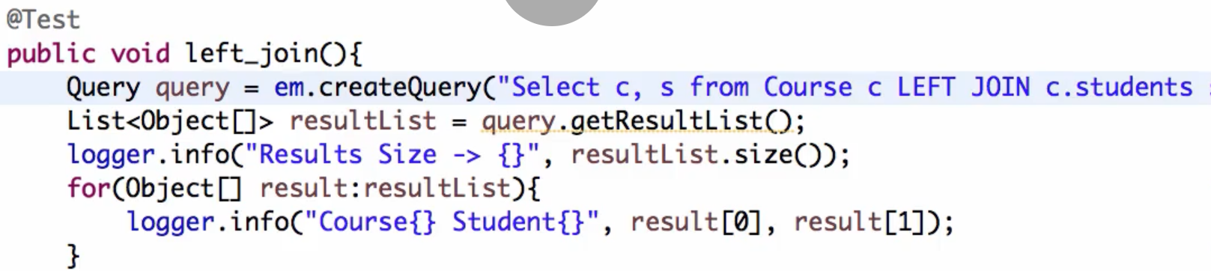

**Transaction Management**

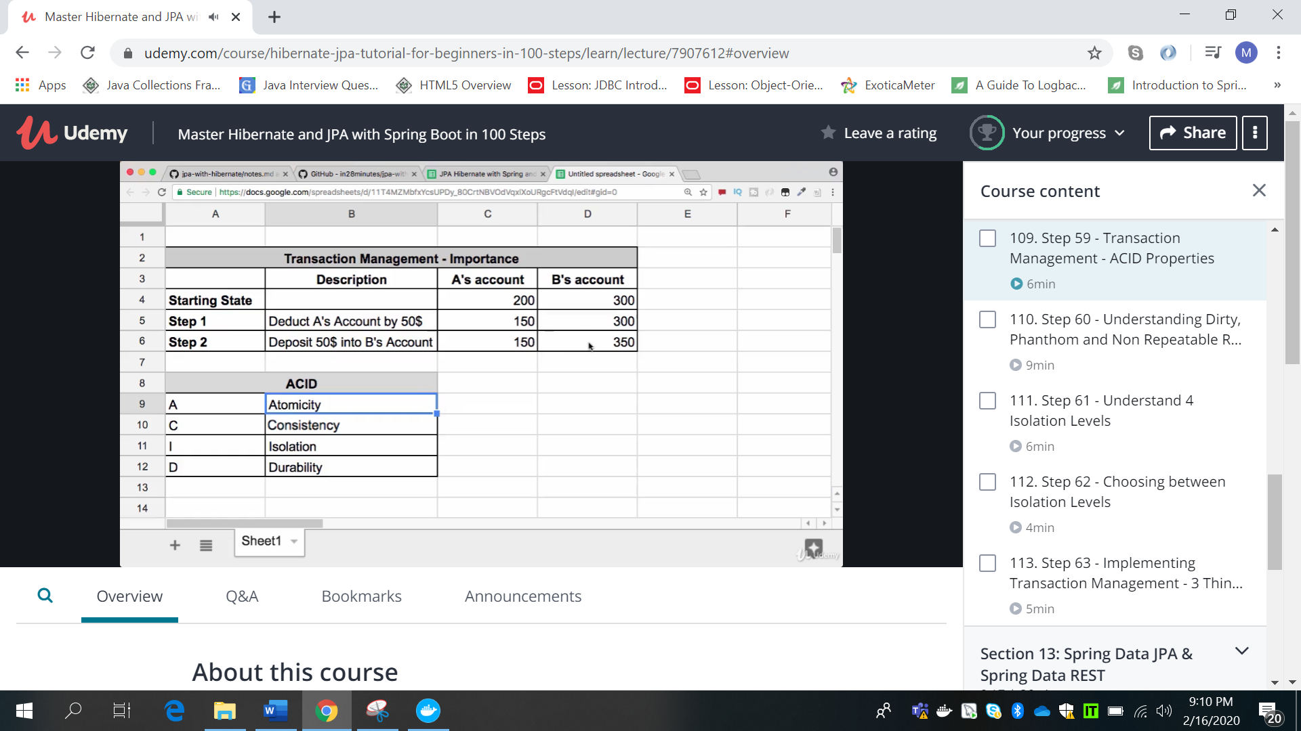

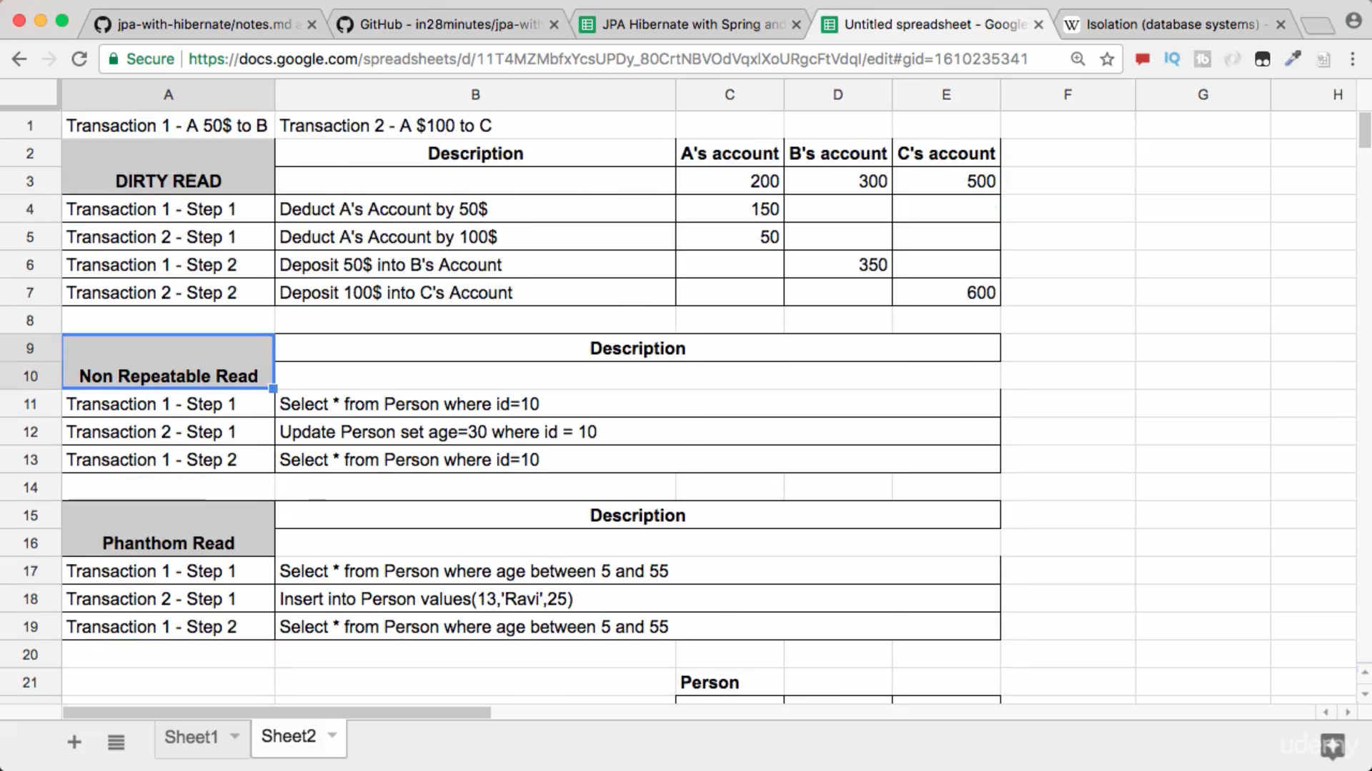

**Dirty Read: Reading non committed updated data is dirty read. Like if transaction 1 deducted A’s account but data is not yet committed, another transaction reads data. In case transaction 1 fails it will roll back to initial state of 1 and changes by transaction 2 will be lost.**

**Non Repeatable Read: If transaction one read some data, after that other transaction updated same record data and in case transaction 1 read same data again it will get different data. Same data is not repeated if read more than once in same ransaction.**

**Phanthom Read: in number of records gets change like above situation then its phanthom read.**

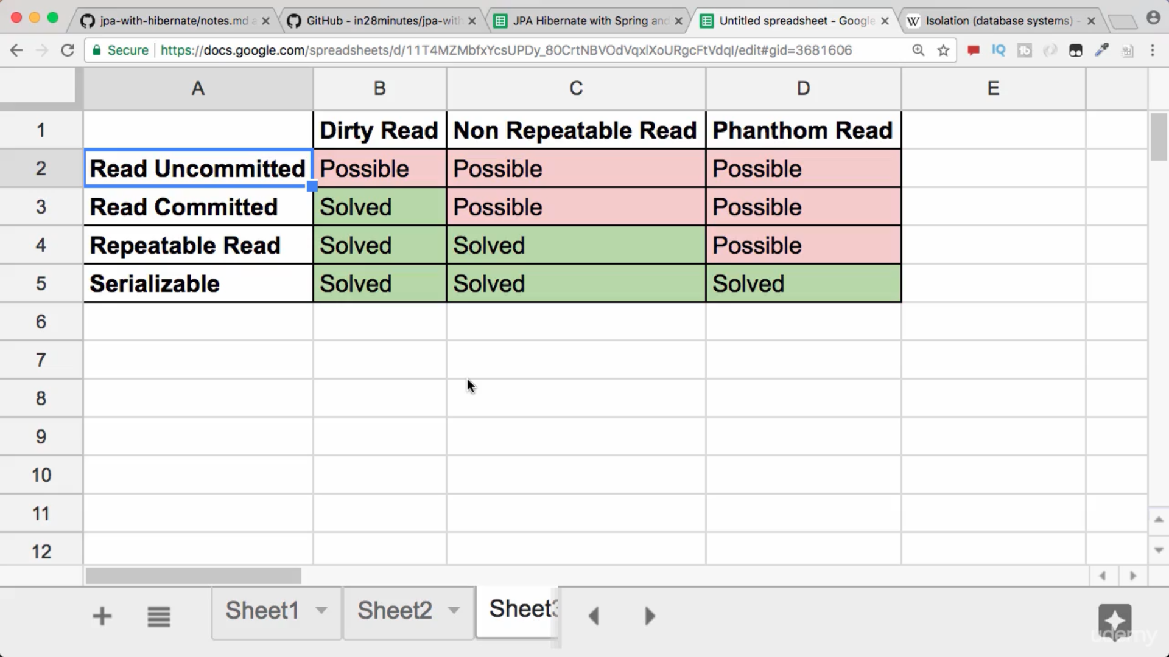

**JAP vs Sprint @Transactional: if w eare interacting with single database both will work but if our business transaction involves multiple databases or MQ etc then spring can manage with its implementation.**

**Isolation level can be changed for any specific transaction like,**

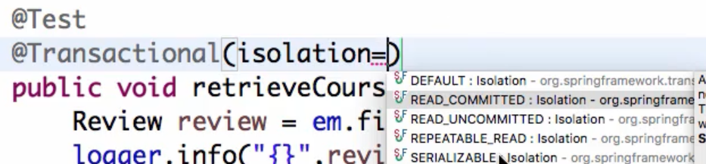

**We can set for all transactions isolation level in application.properties.**



**Spring Data JPA**

**Respository classes have repetative code, and manually need to do it with em.**

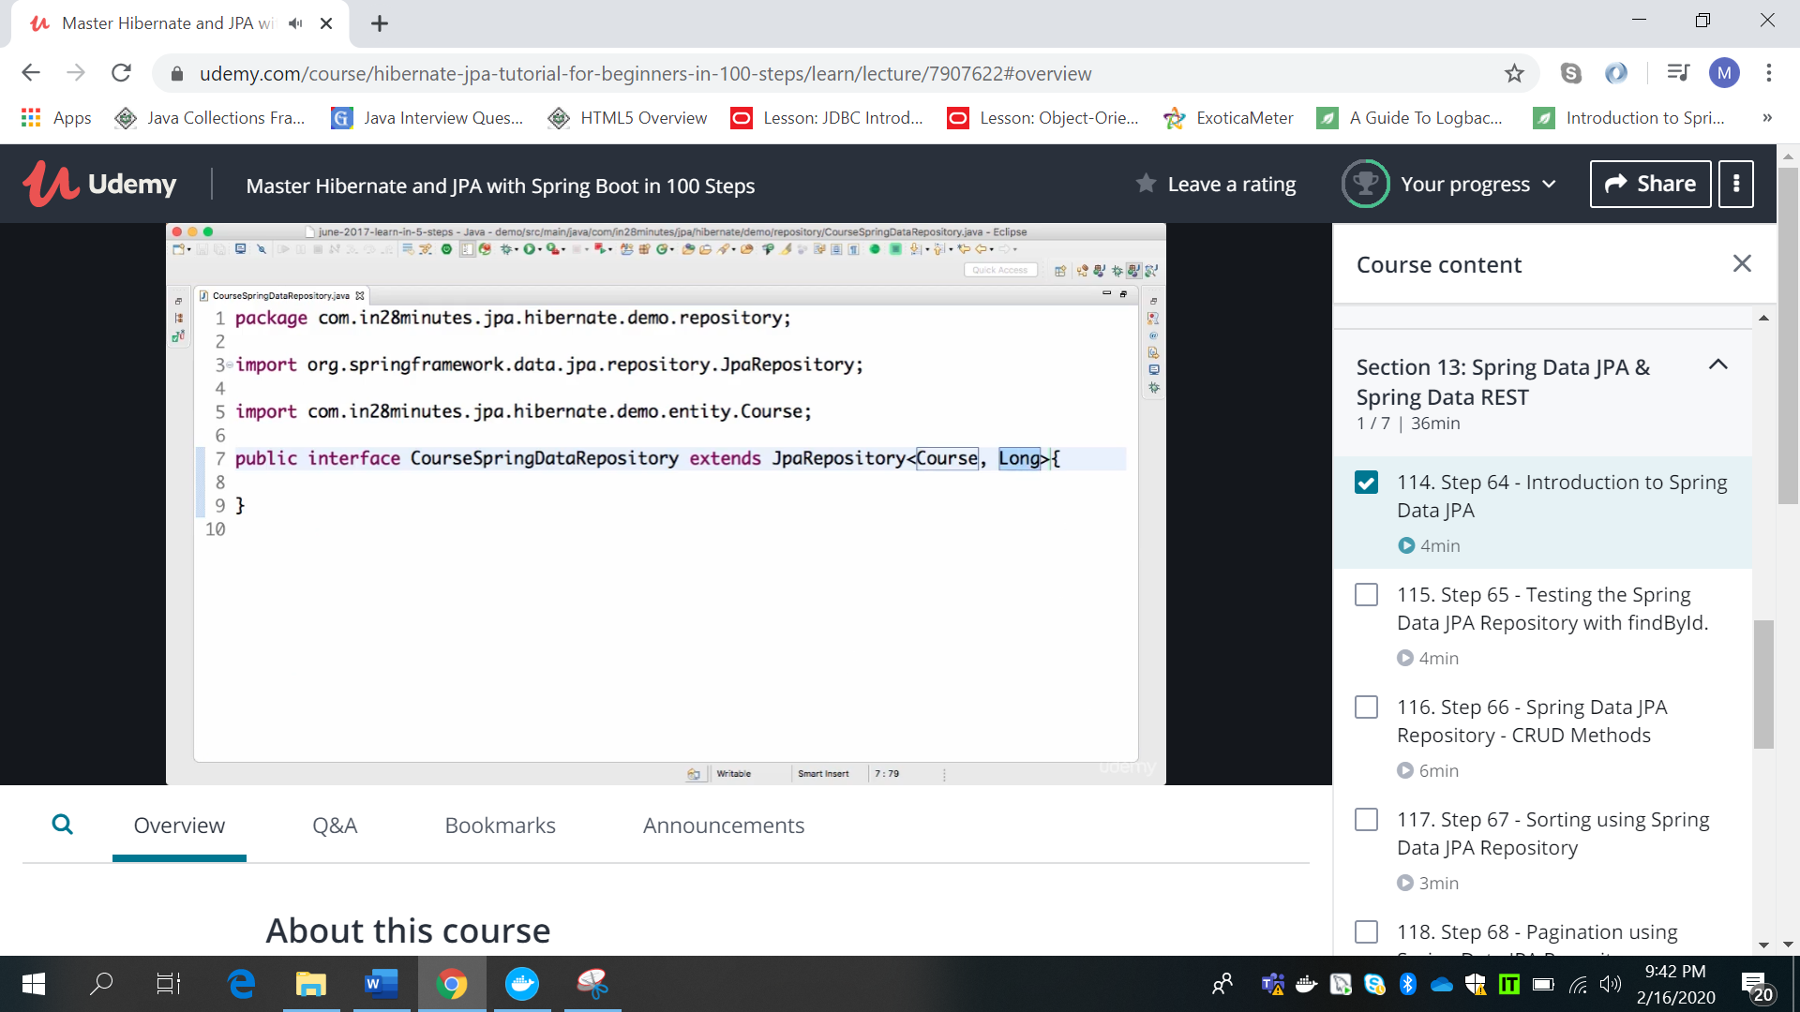

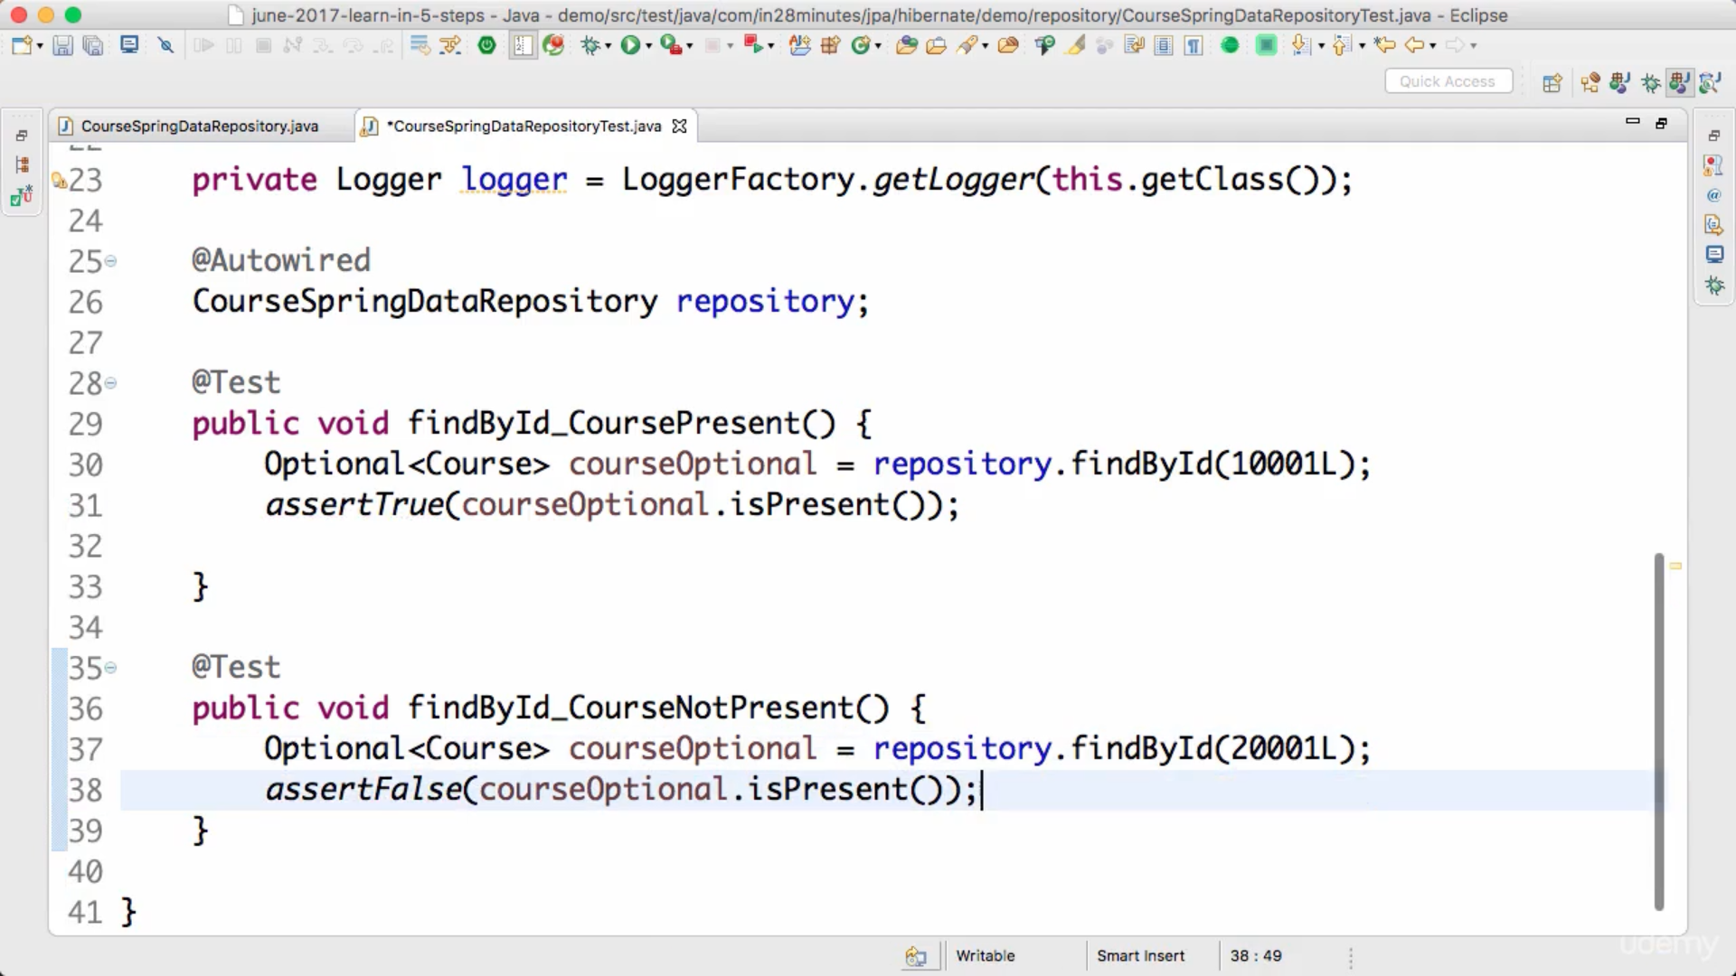

**Optional saves us from nulls.**

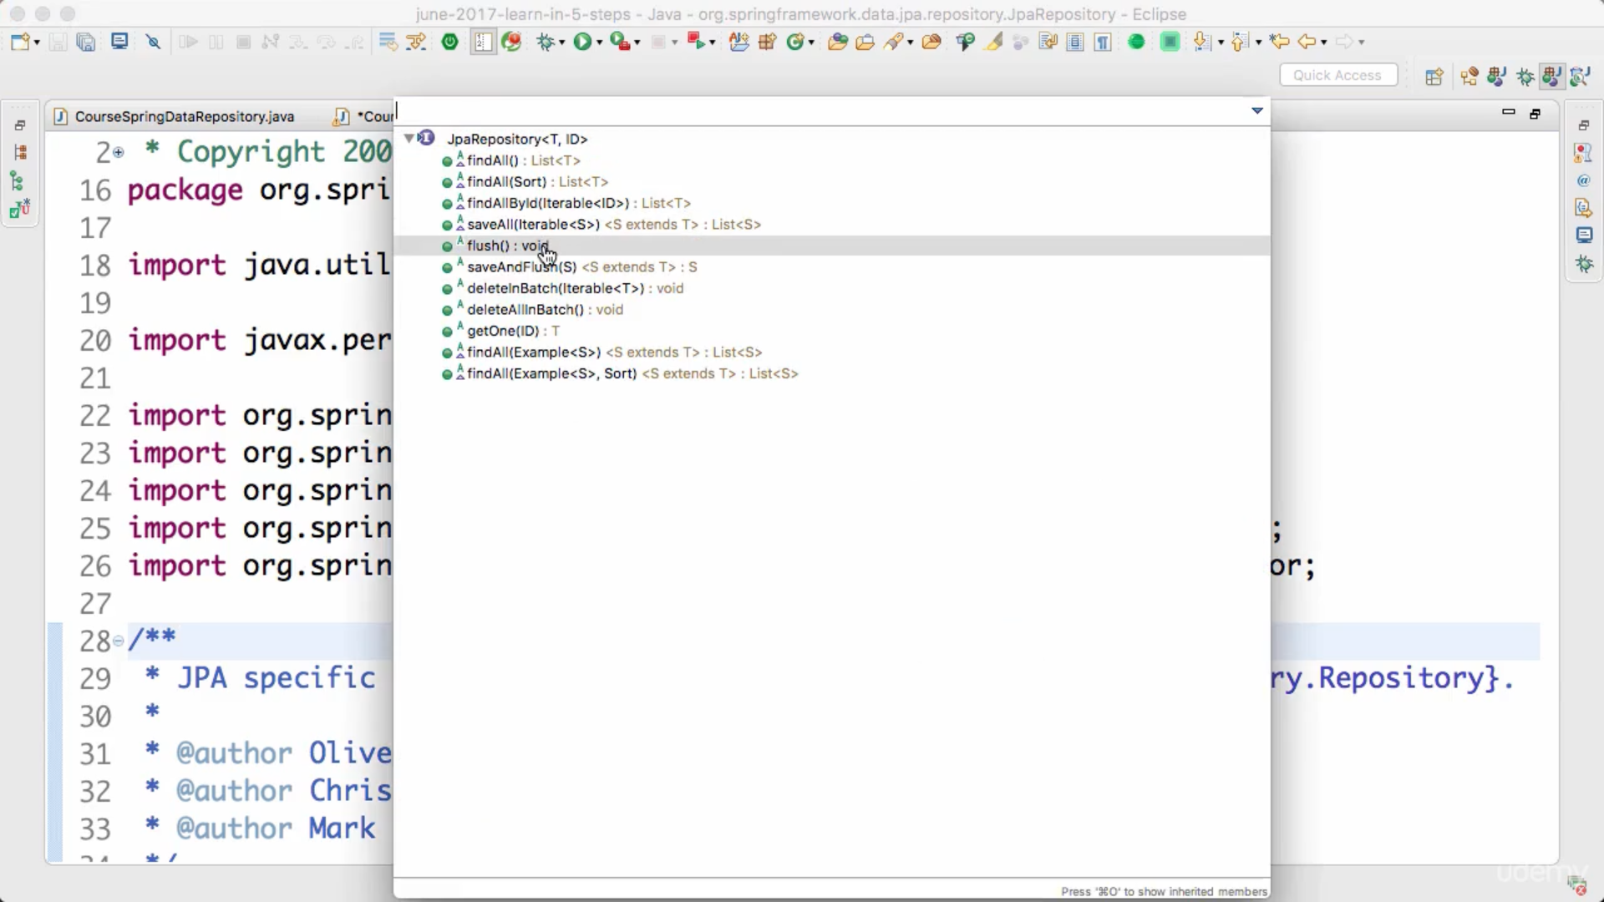

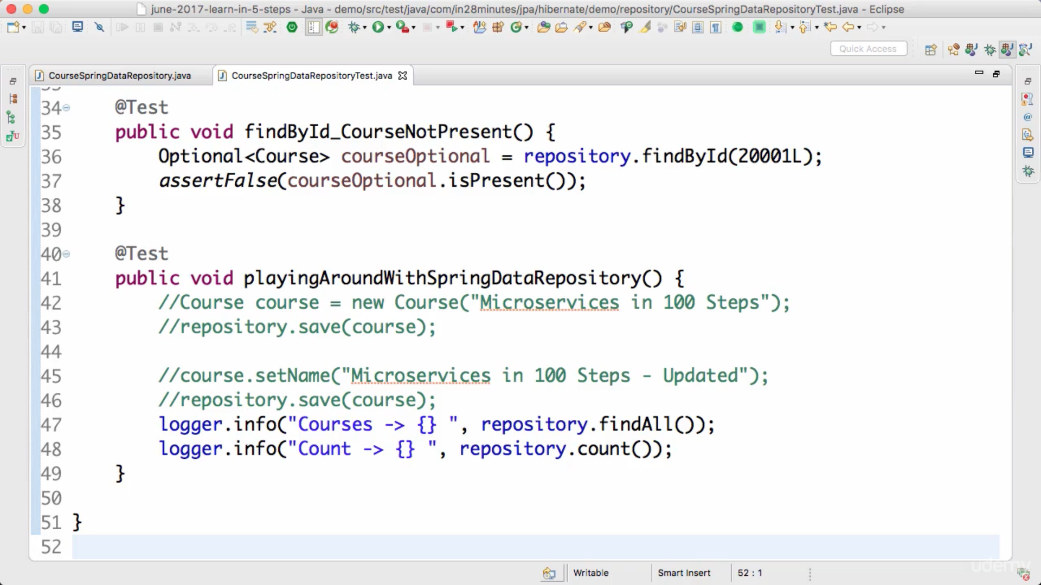

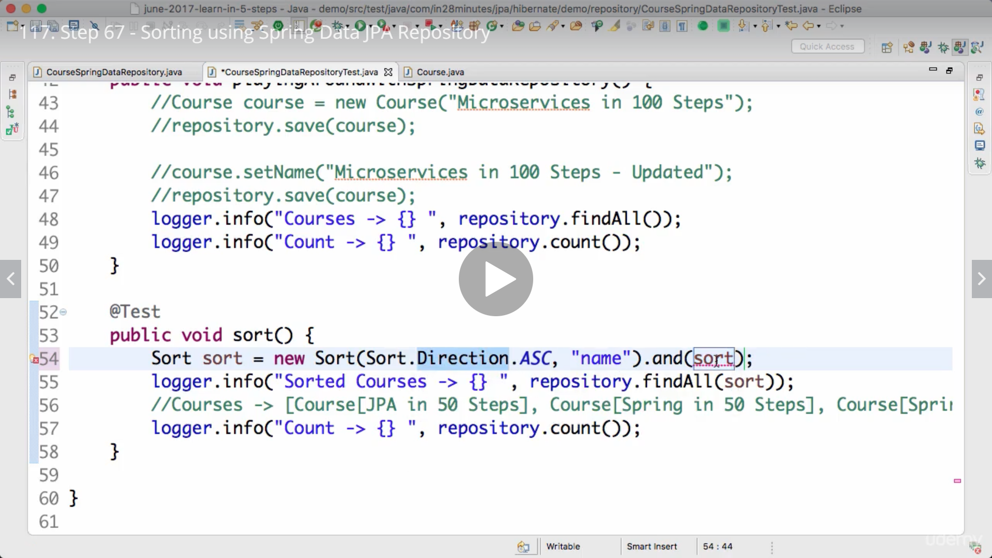

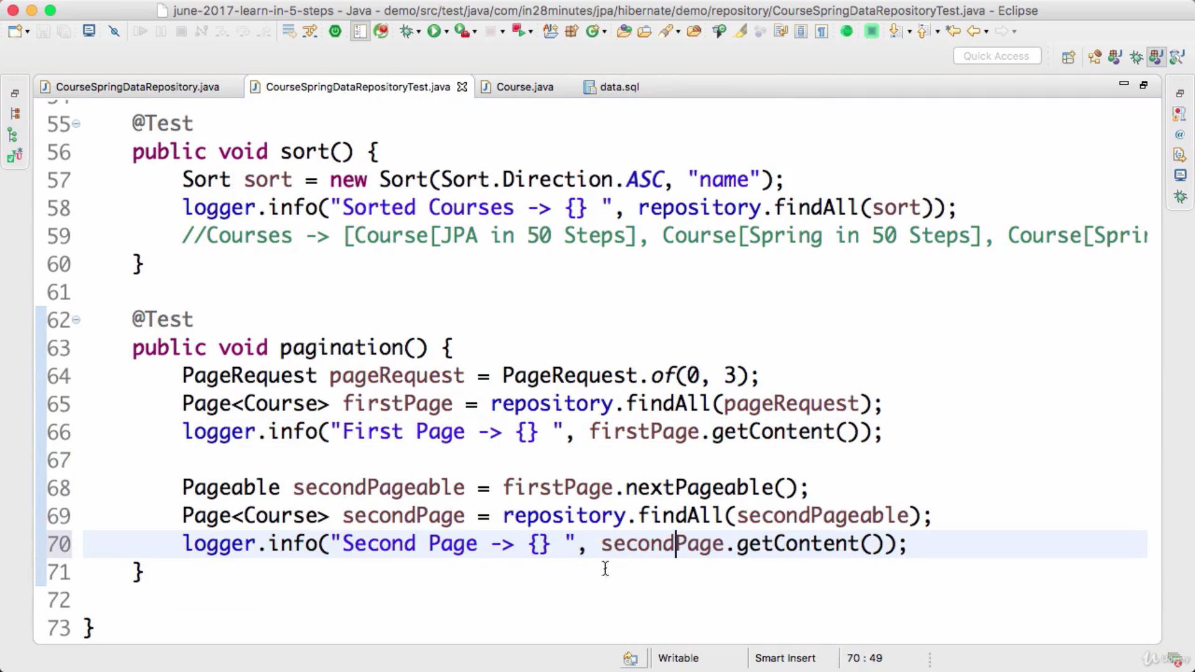

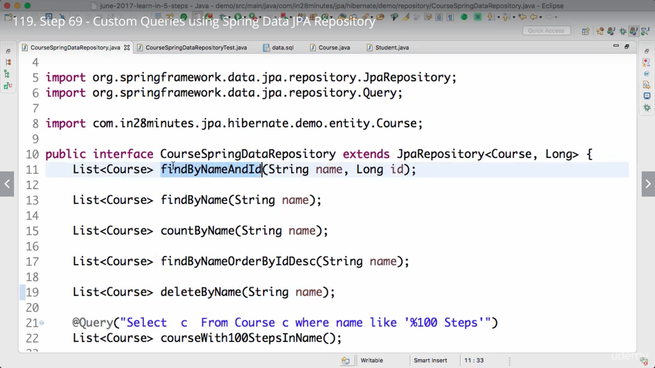

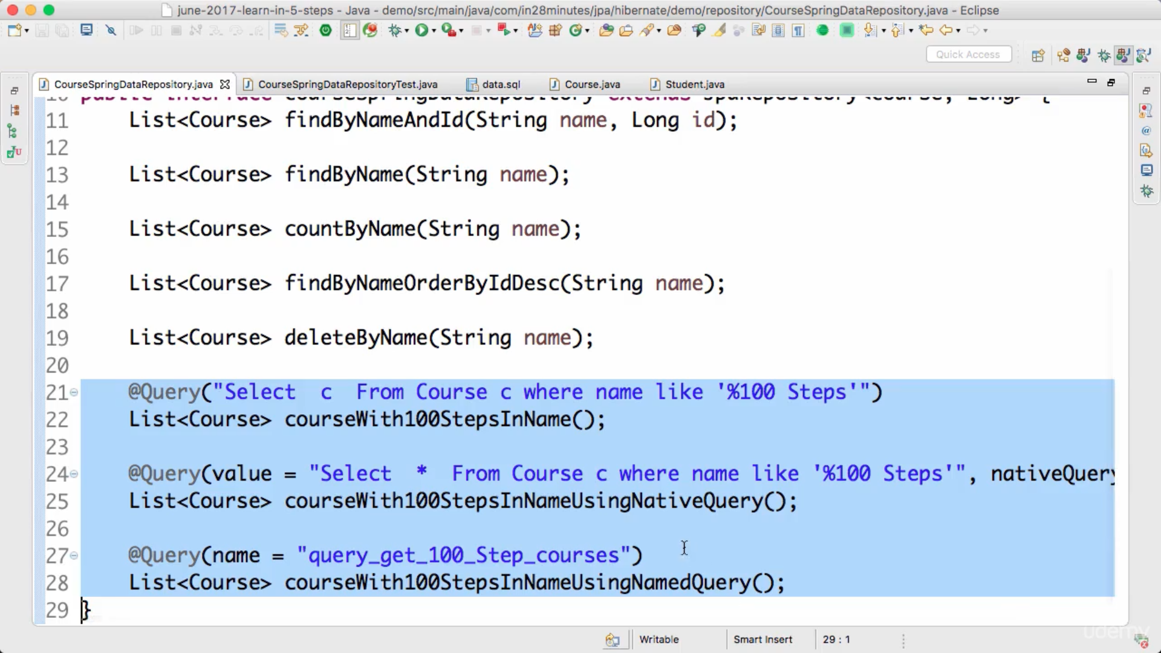

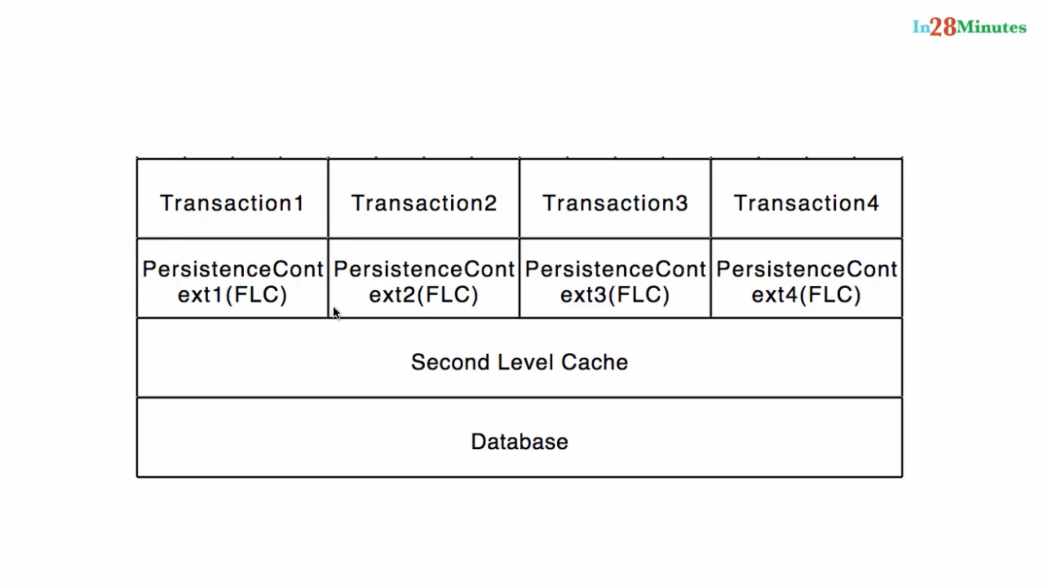

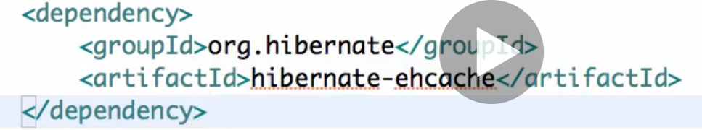

**Everything will not be cached in second level cache.**

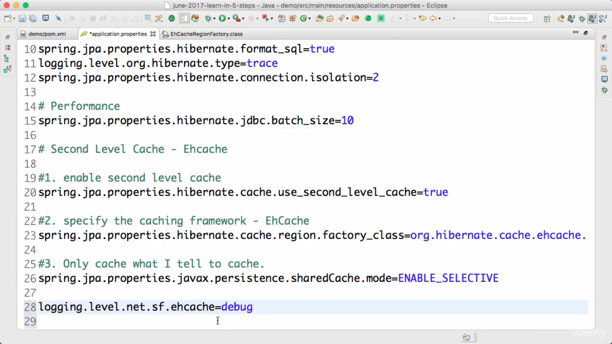

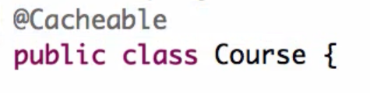

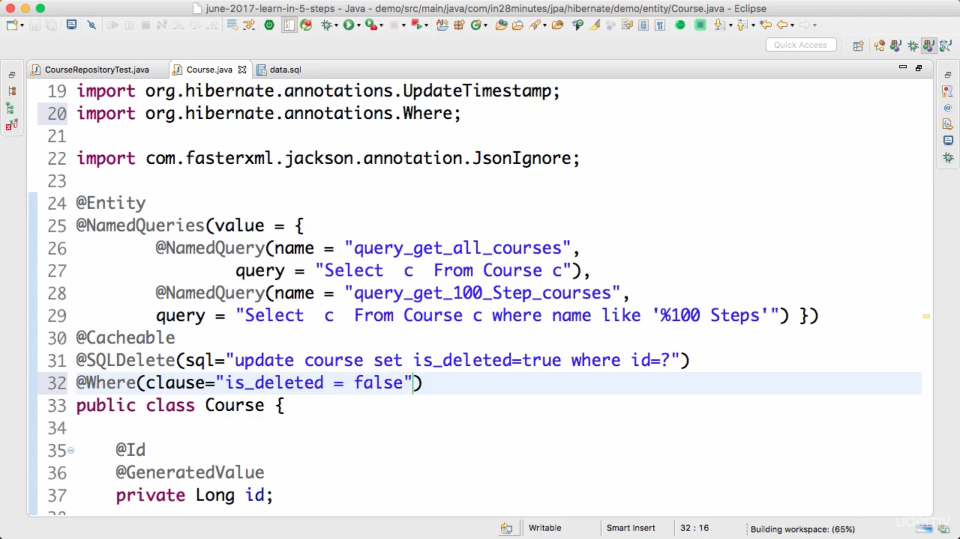

**Native query need to be corrected manually to handle soft deletes, in case of deletes cache entity not gets updates only sql is modified for soft delete mechanishm.**

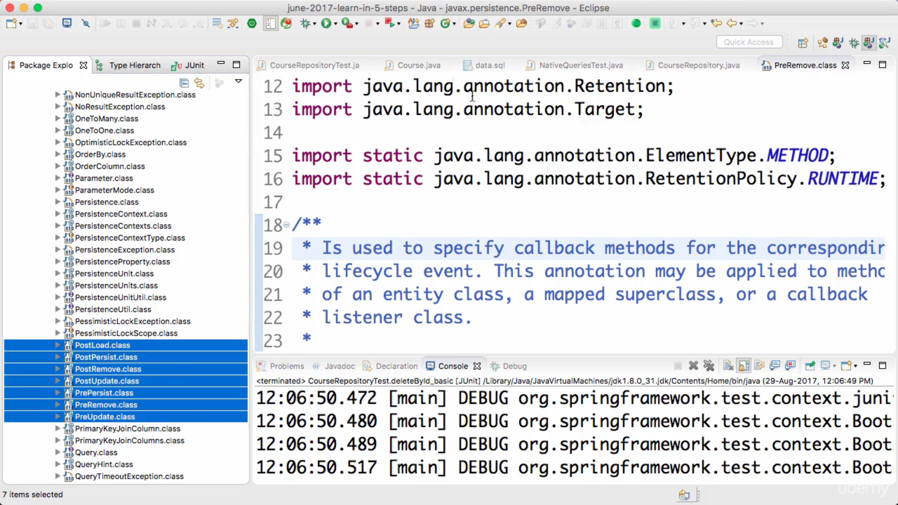

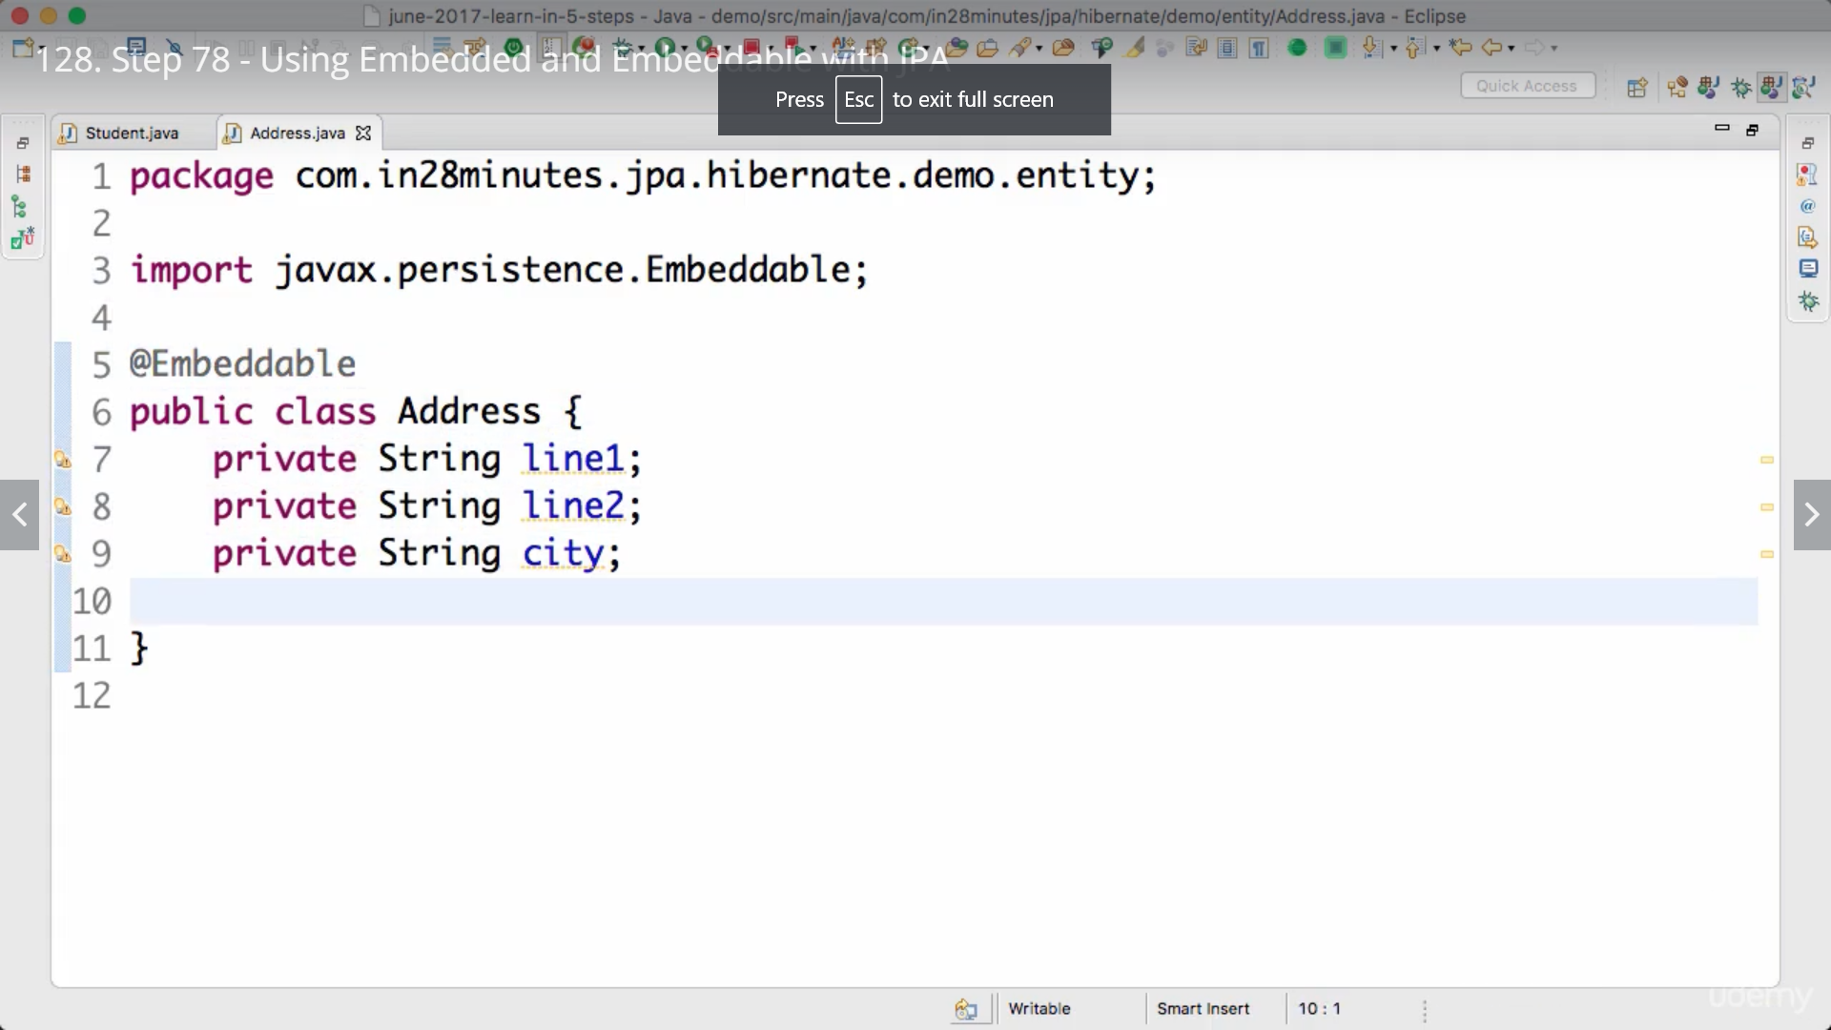

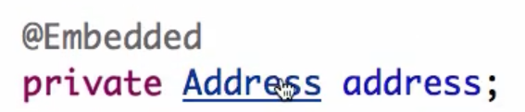

**Will store data off address columns in same student table.**

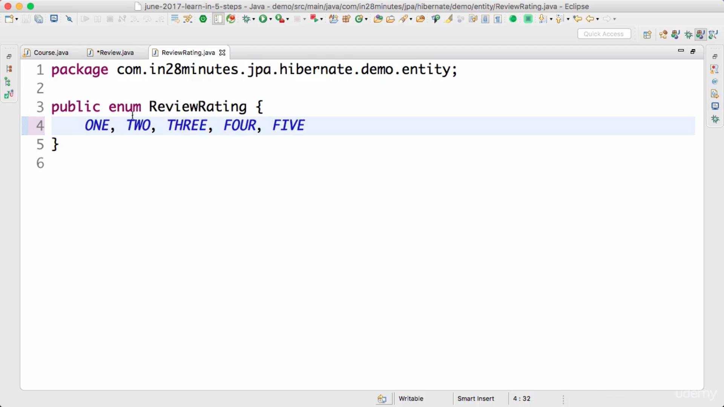

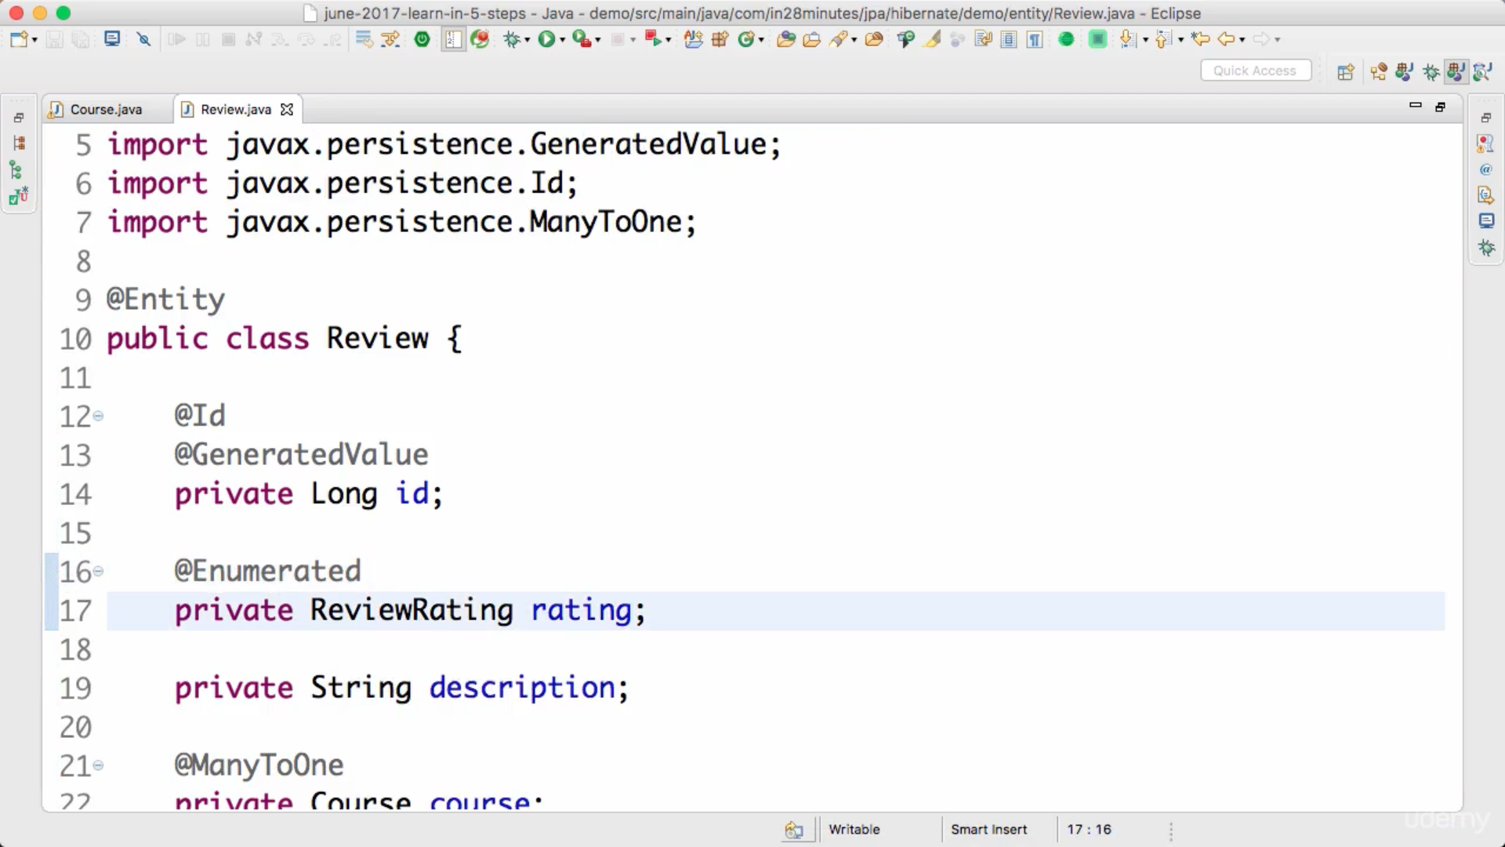

**By default enum ordinal will be saved in database. But ordinal may change if we update enum.**

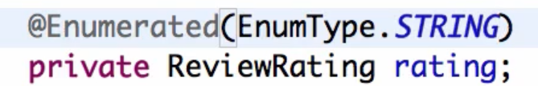

**In tostring never use mapped entities, otherwise it will fetch that data even if we need main entity only.**

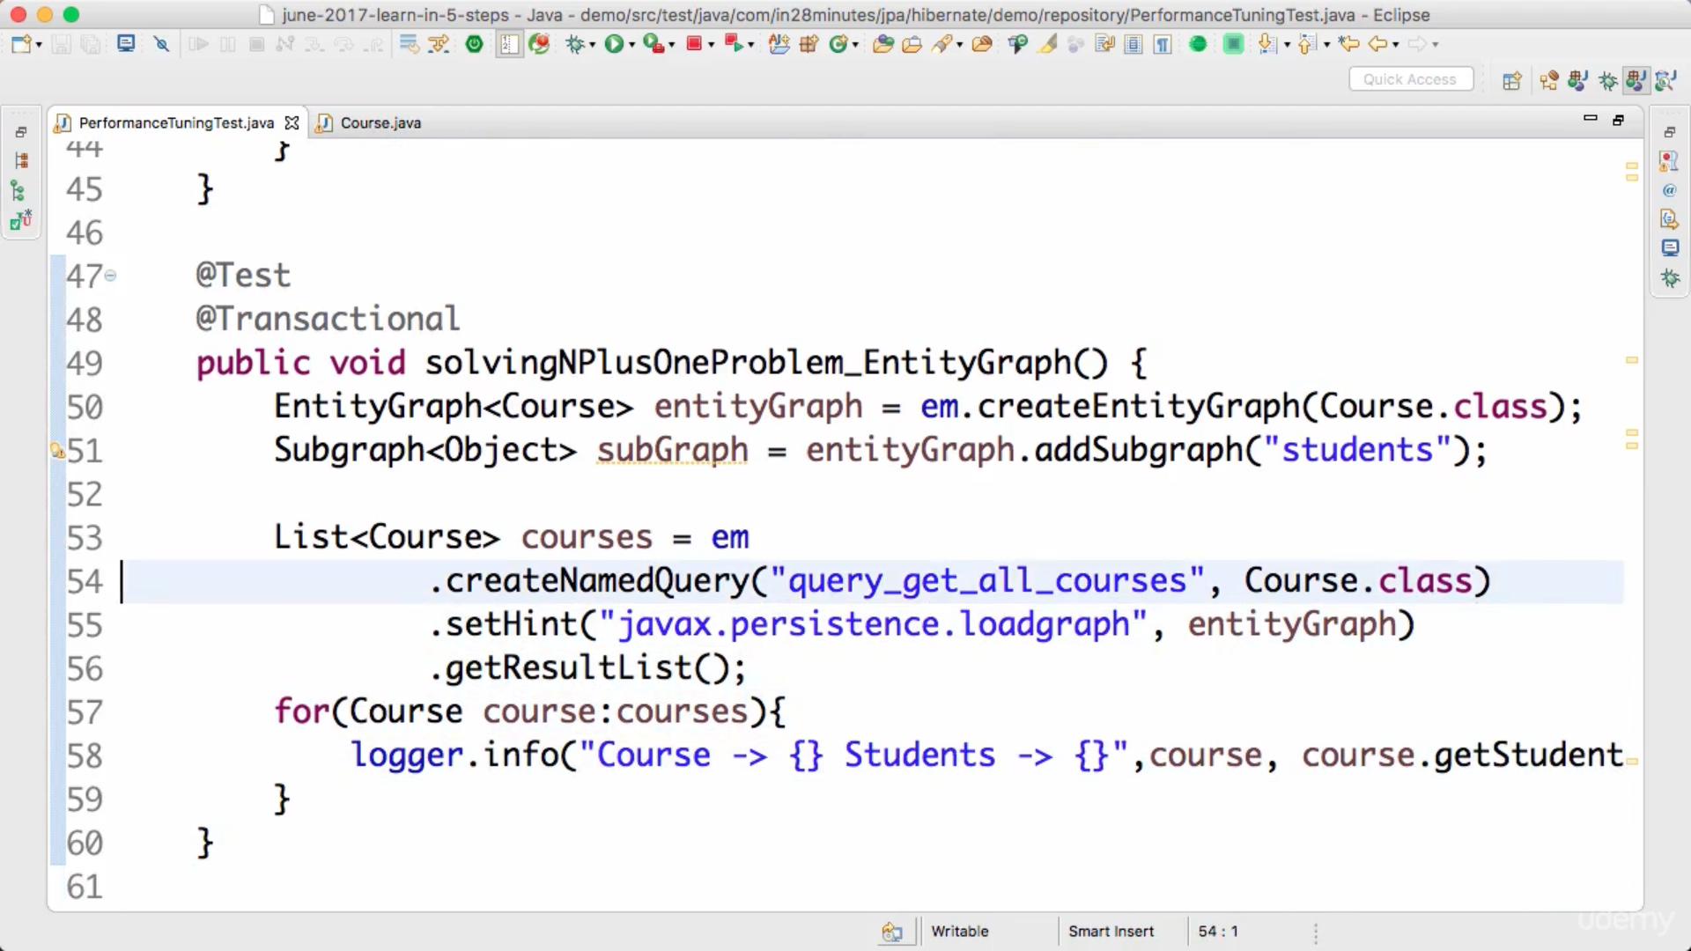

**Alternate approach is join fetch, define new named query on course.**

